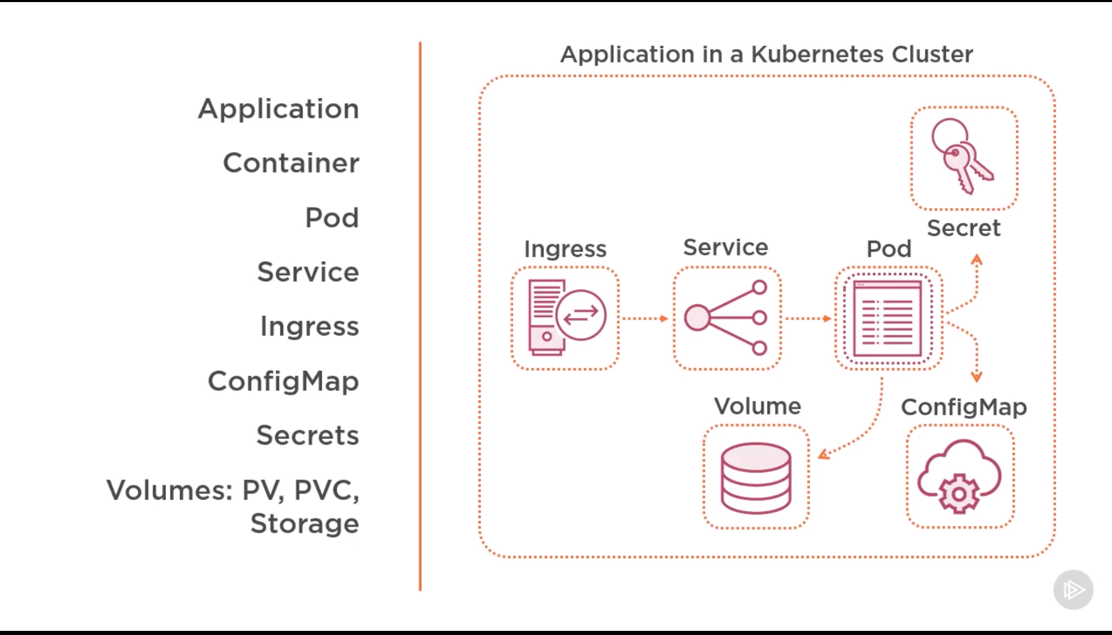

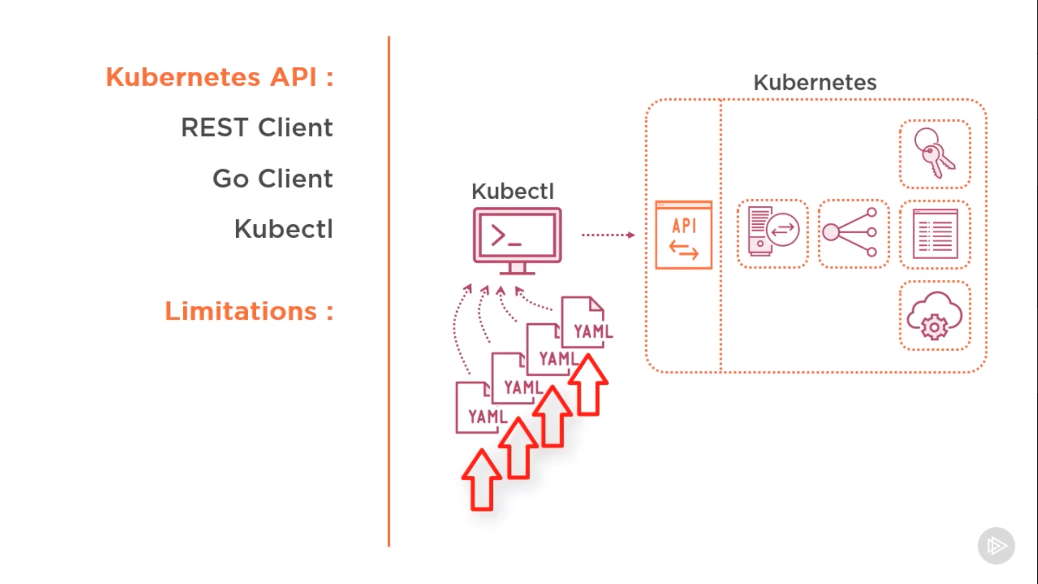

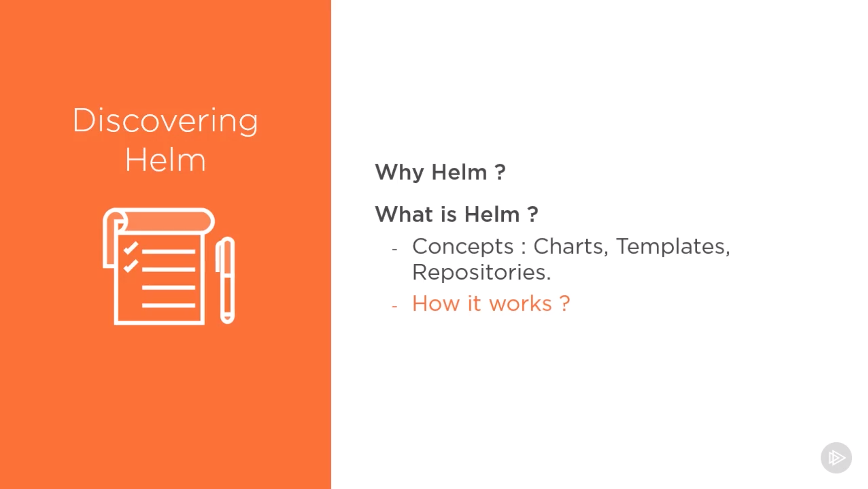

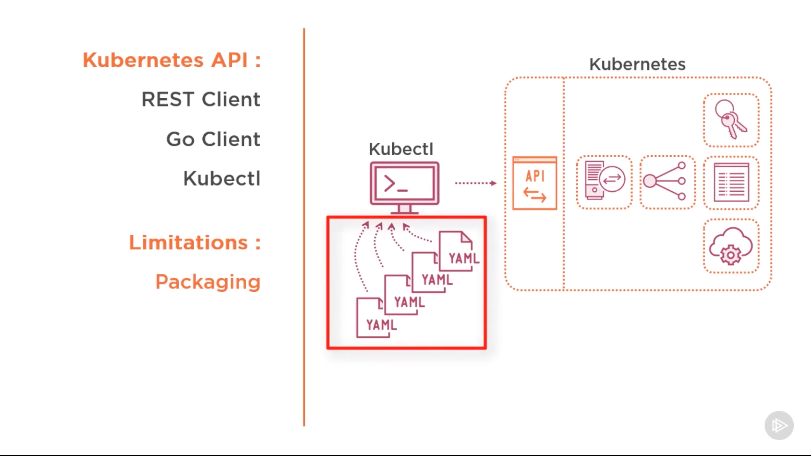

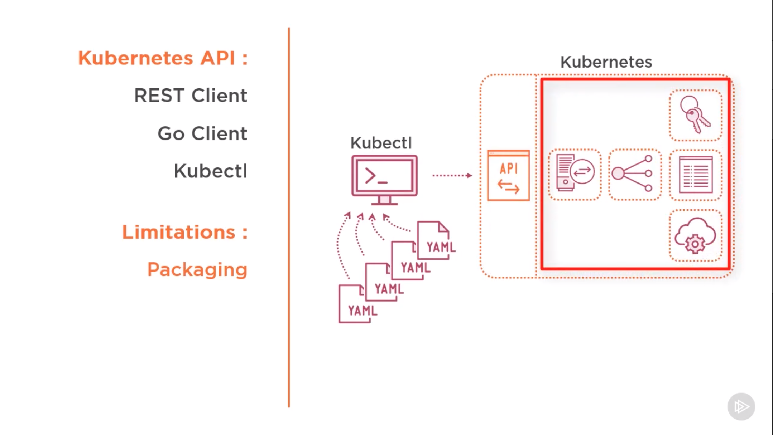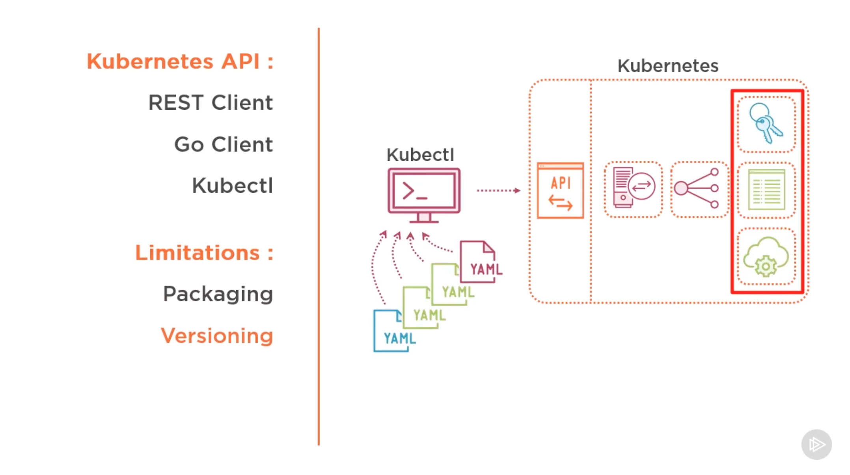

**Helm and Kubernetes**

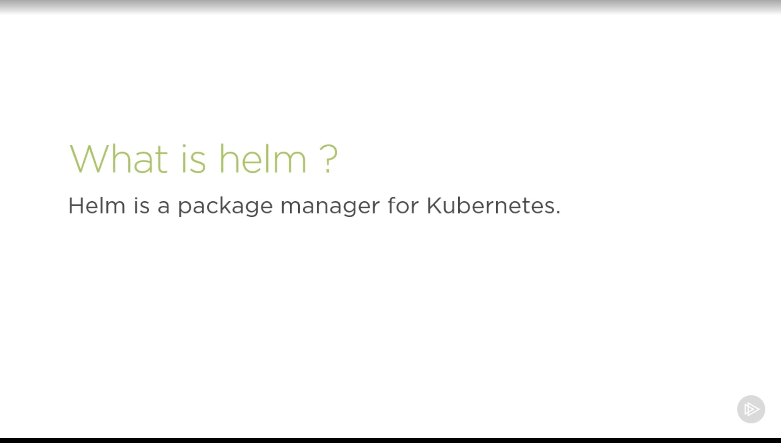

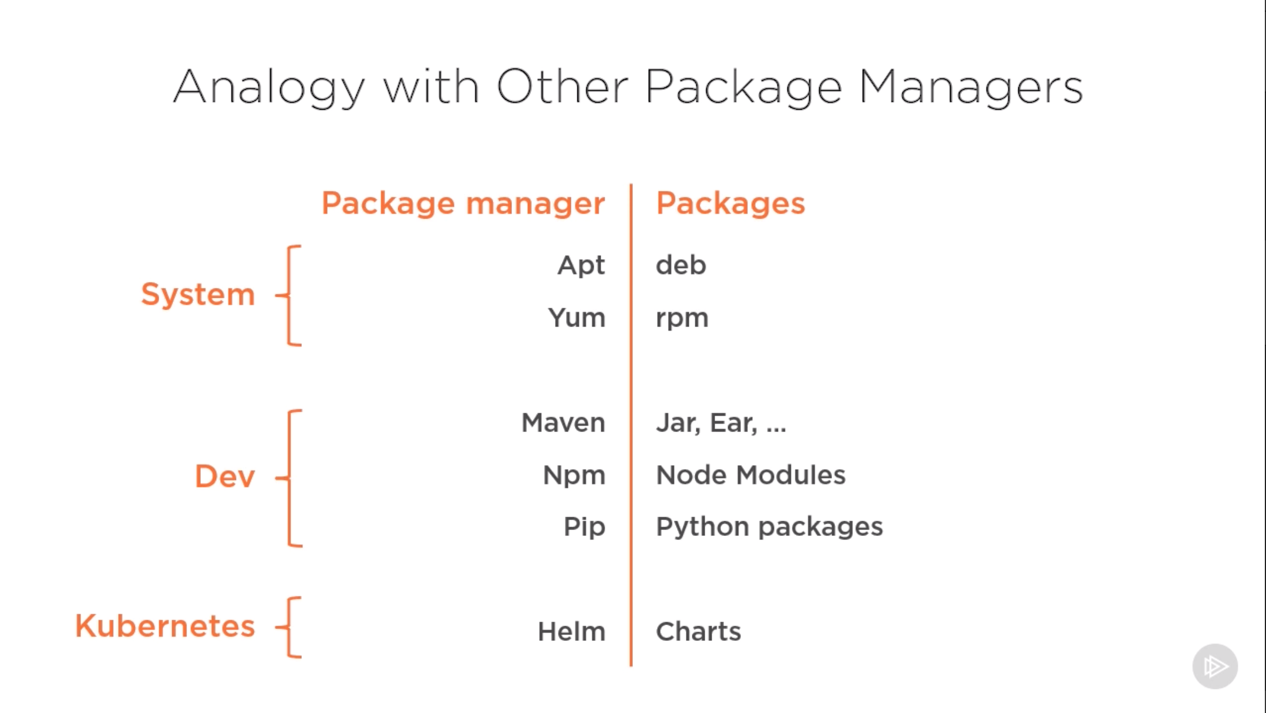

* Helm is a package manager for kubernetes.
* Package managers automate the process of installing, configuring, upgrading, and removing computer programs.
* Examples include the Red Hat® Package Manager (RPM), Homebrew, and Windows® Package Management.
* An application in Kubernetes typically consists of at least two resource types: a *deployment* resource, which describes a set of pods to be deployed together, and a *services* resource, which defines endpoints for accessing the APIs in those pods.
* The application can also include ConfigMaps, Secrets, and Ingress.
* For any deployment, you need several Kubernetes commands (kubectl) to create and configure resources.
* Instead of manually creating each resource separately, you can create many resources with one command.
* A Helm *chart* defines several Kubernetes resources as a set.
* A default chart has a minimum of a deployment template and a service template.

**Helm components and terminology**

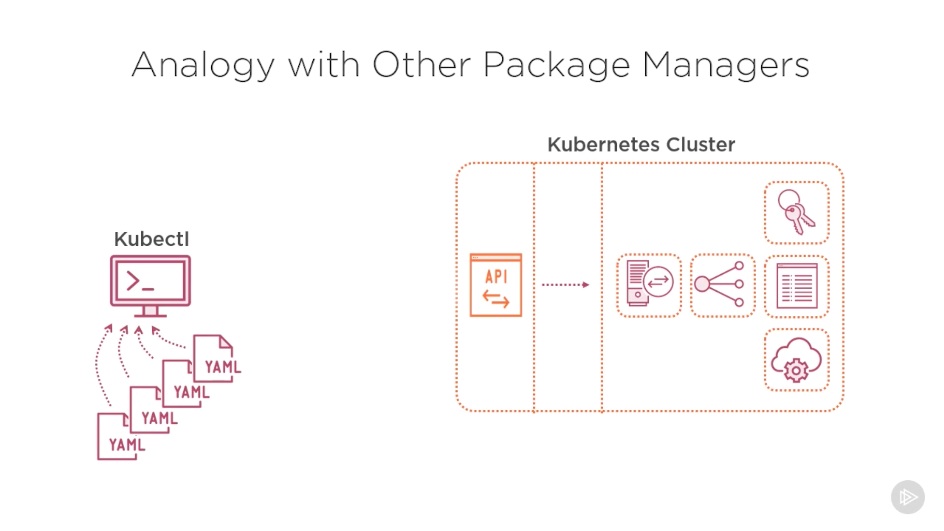

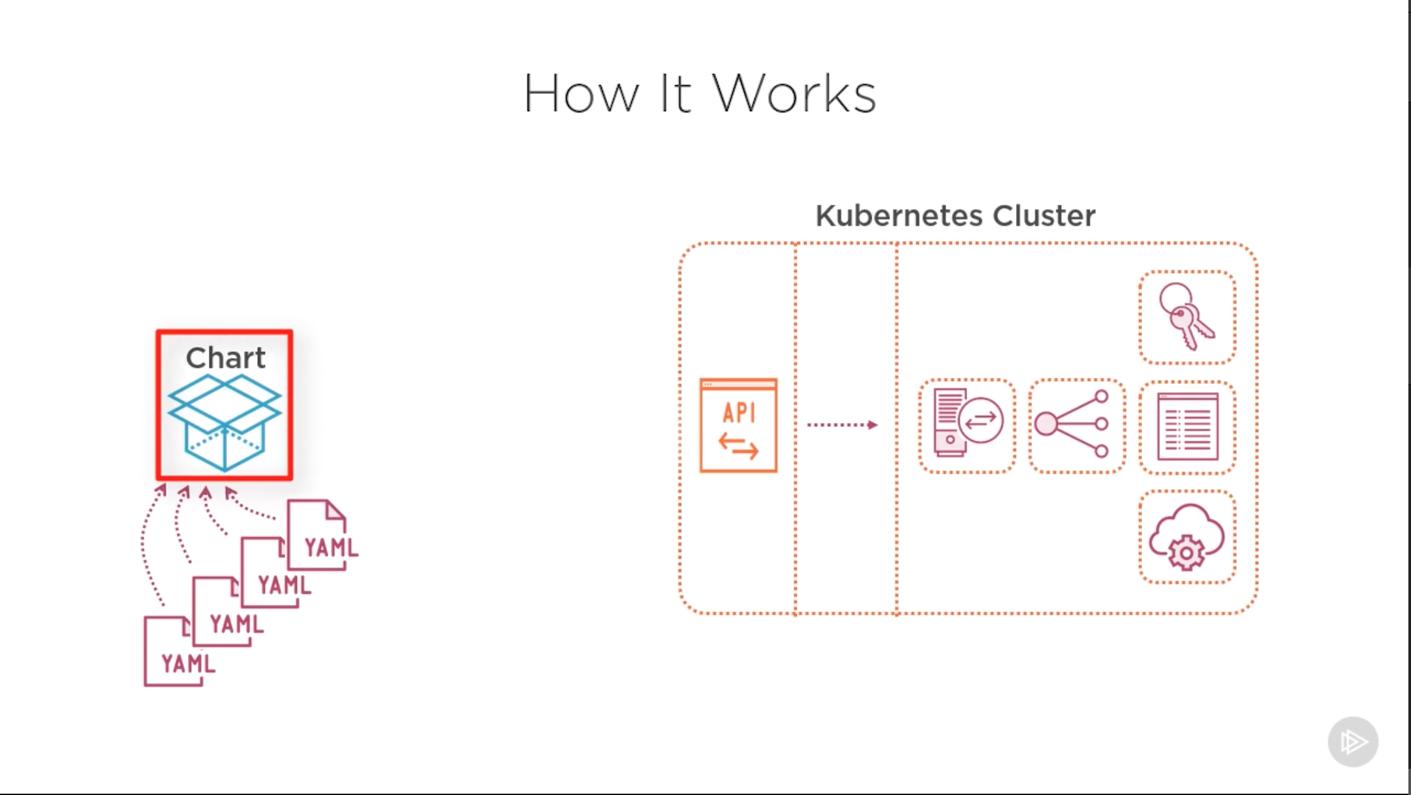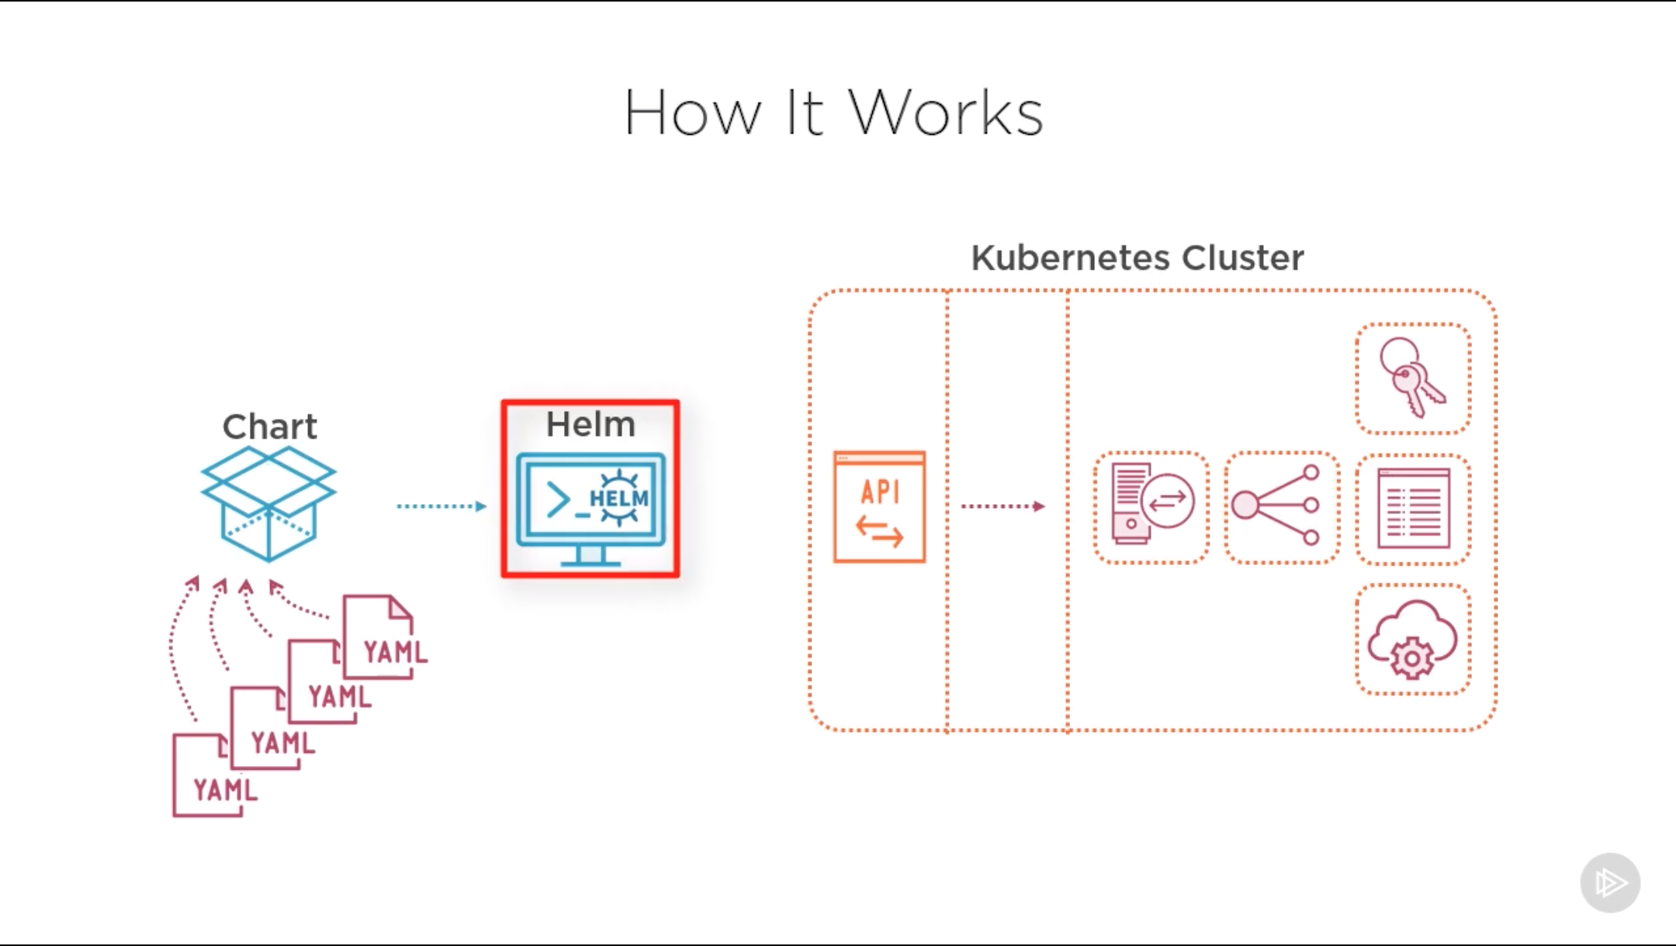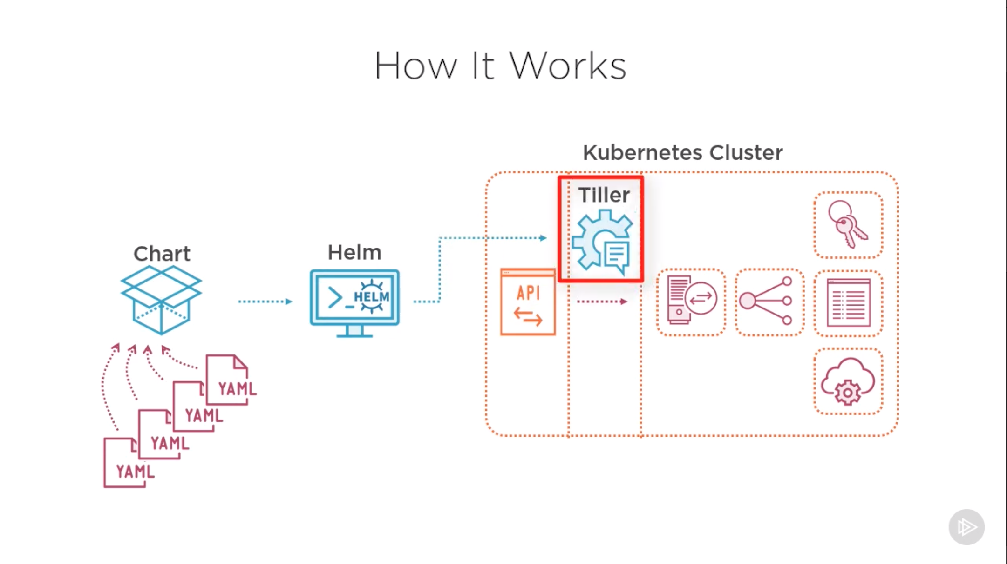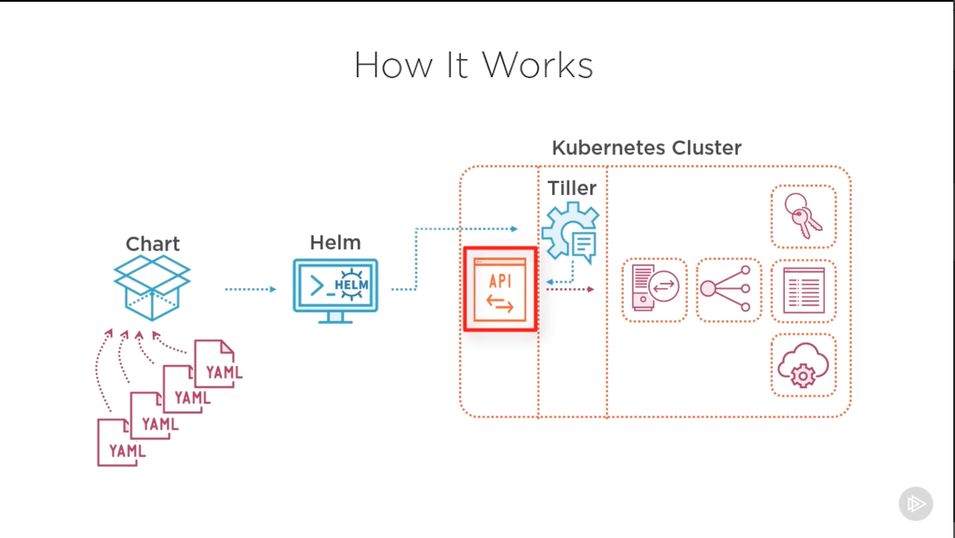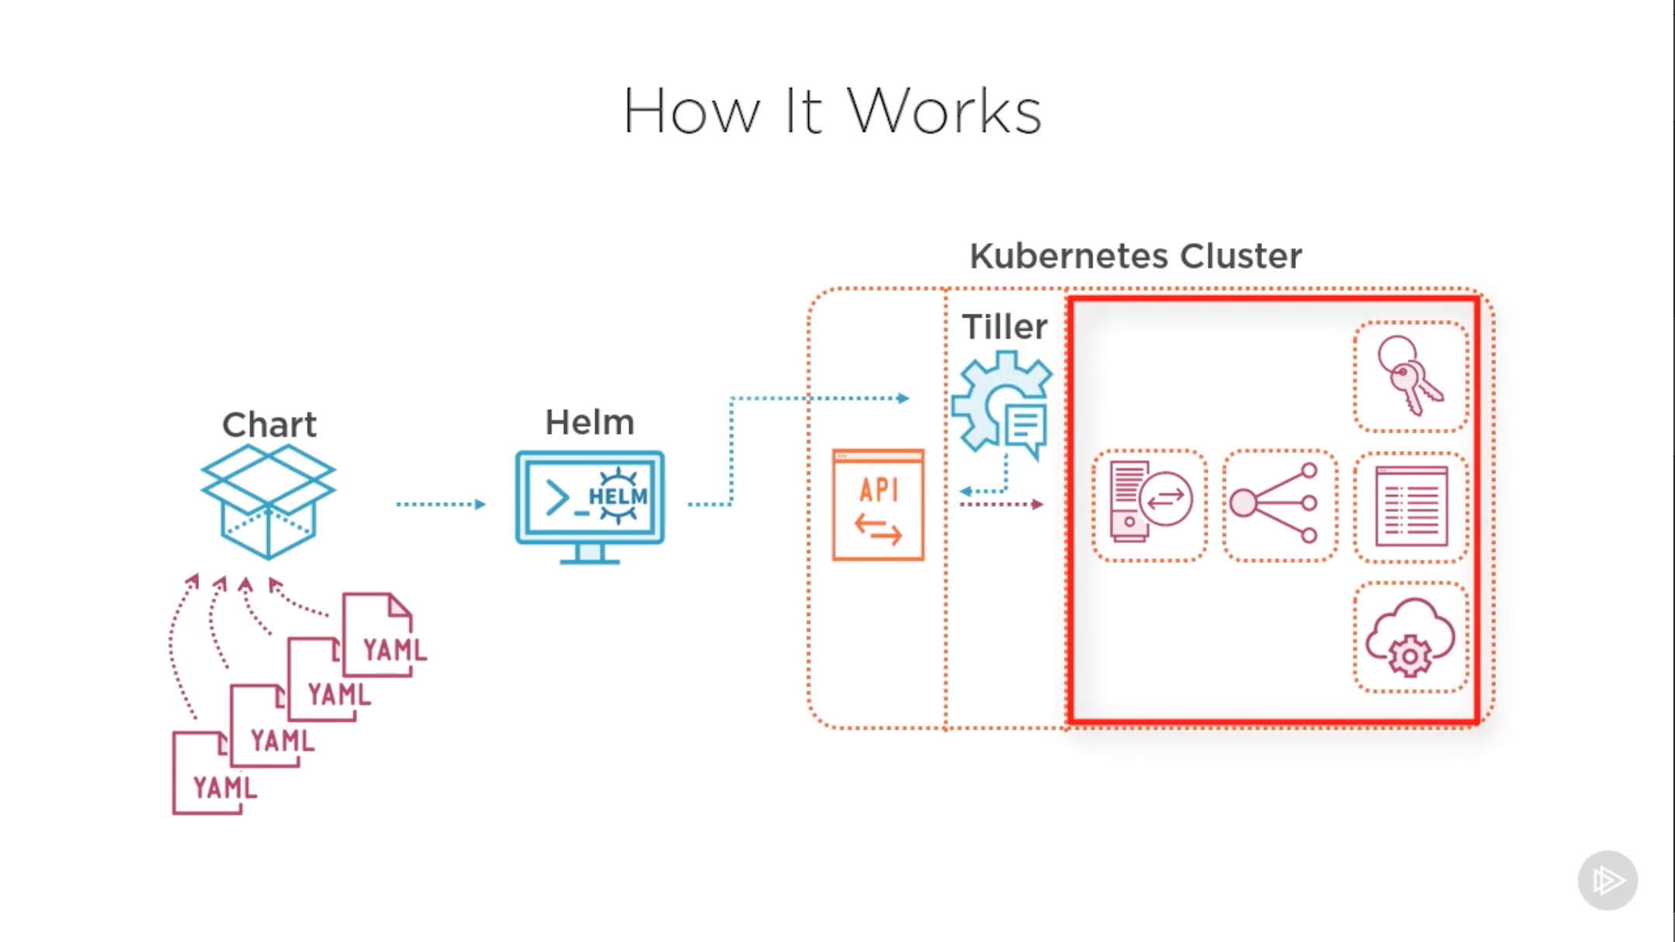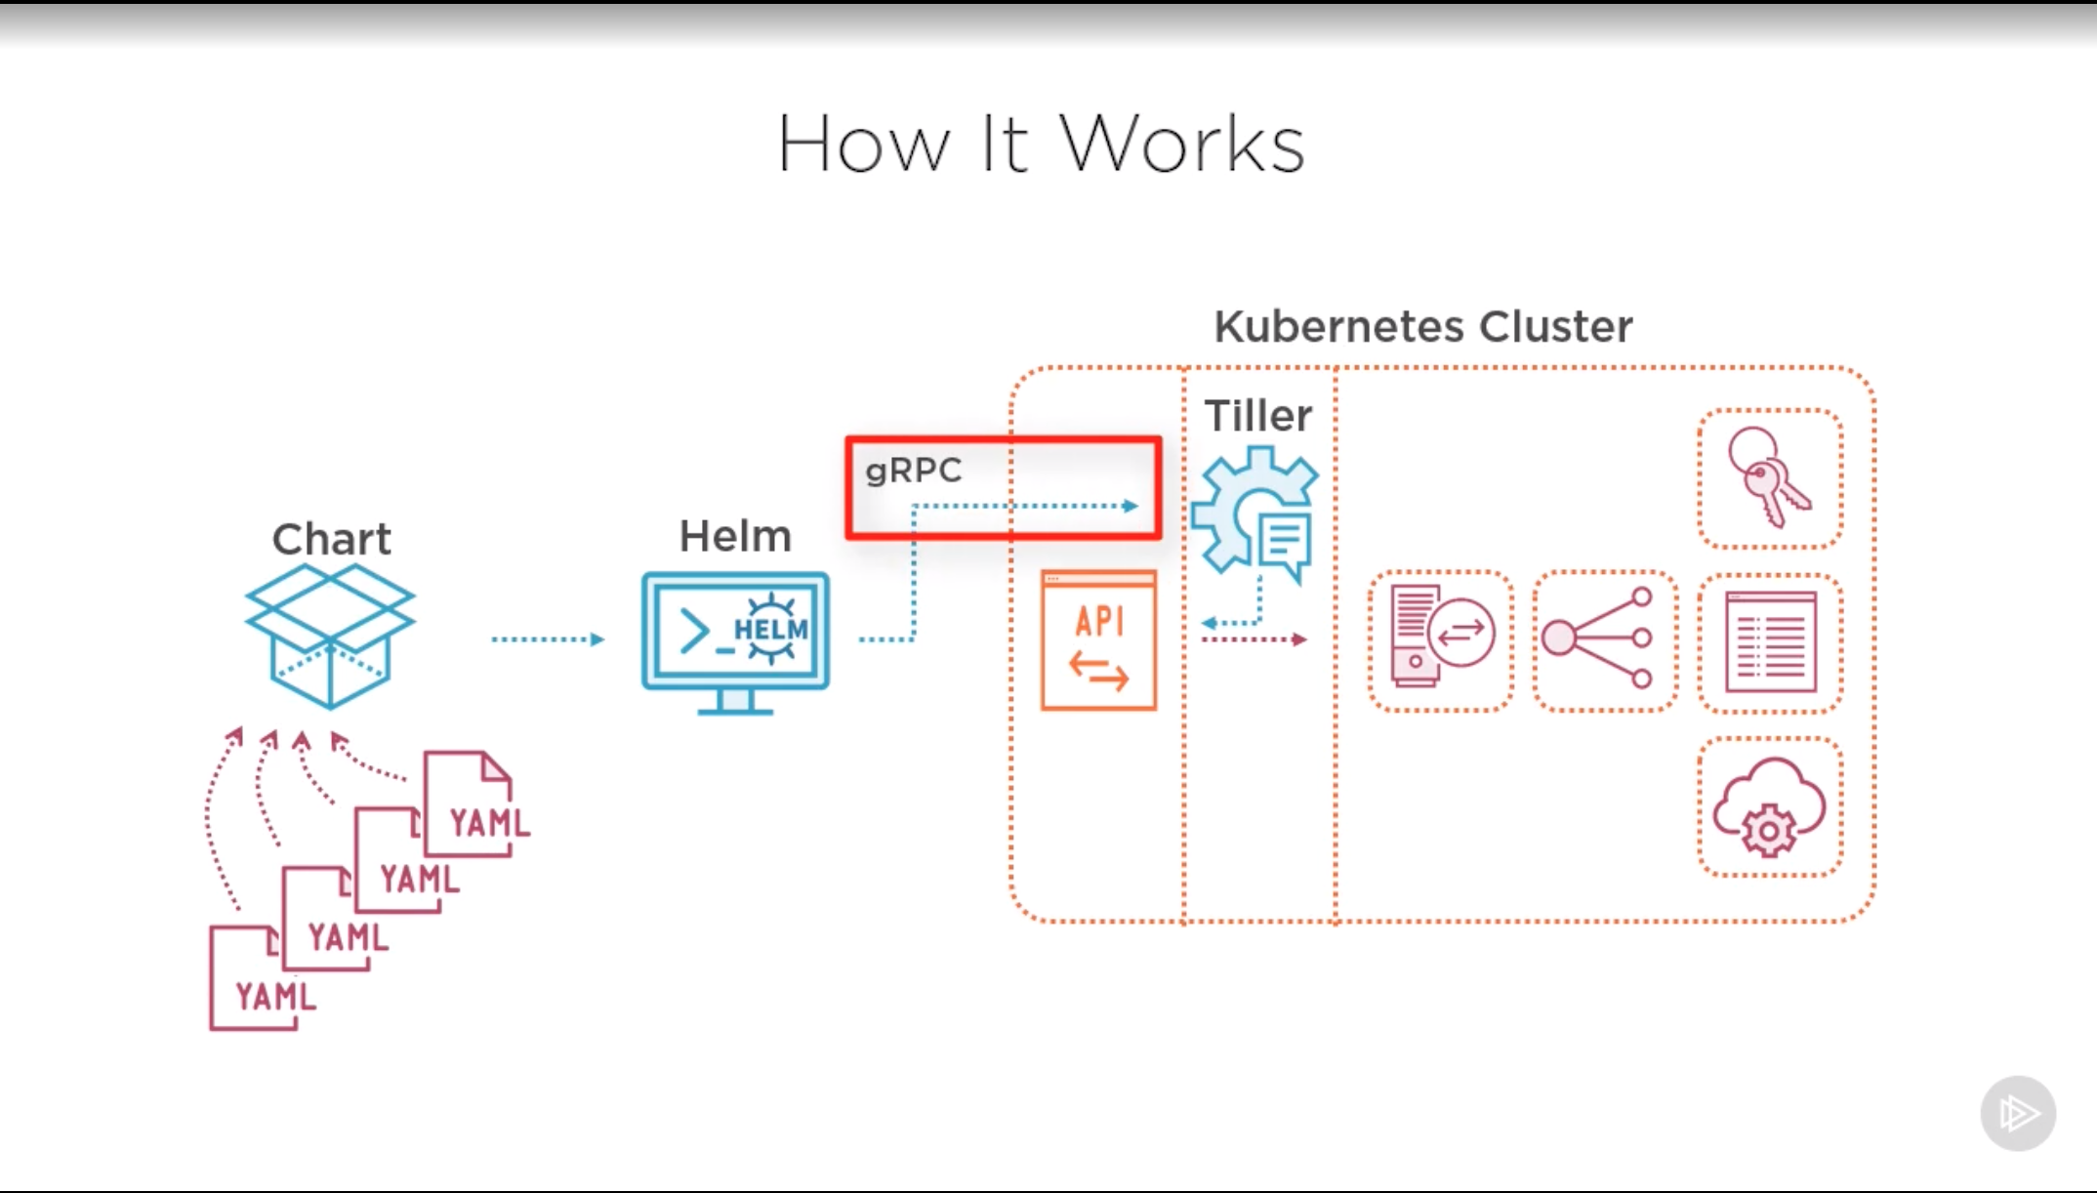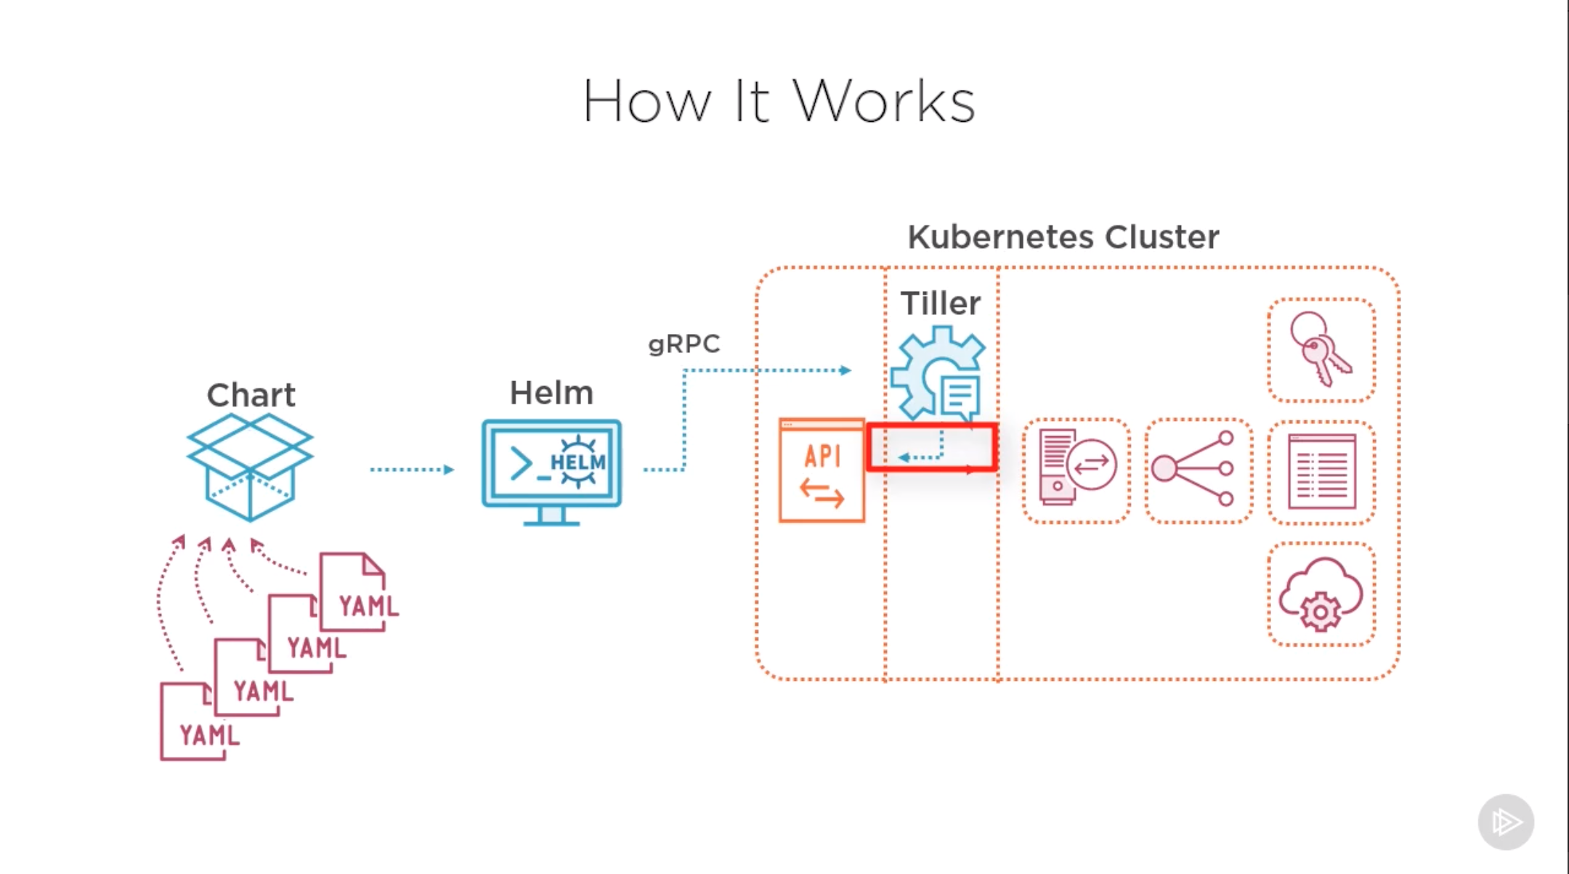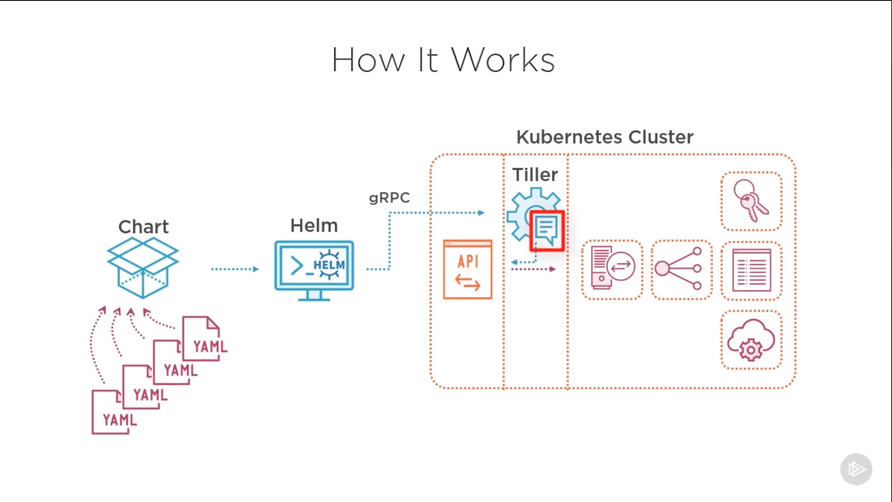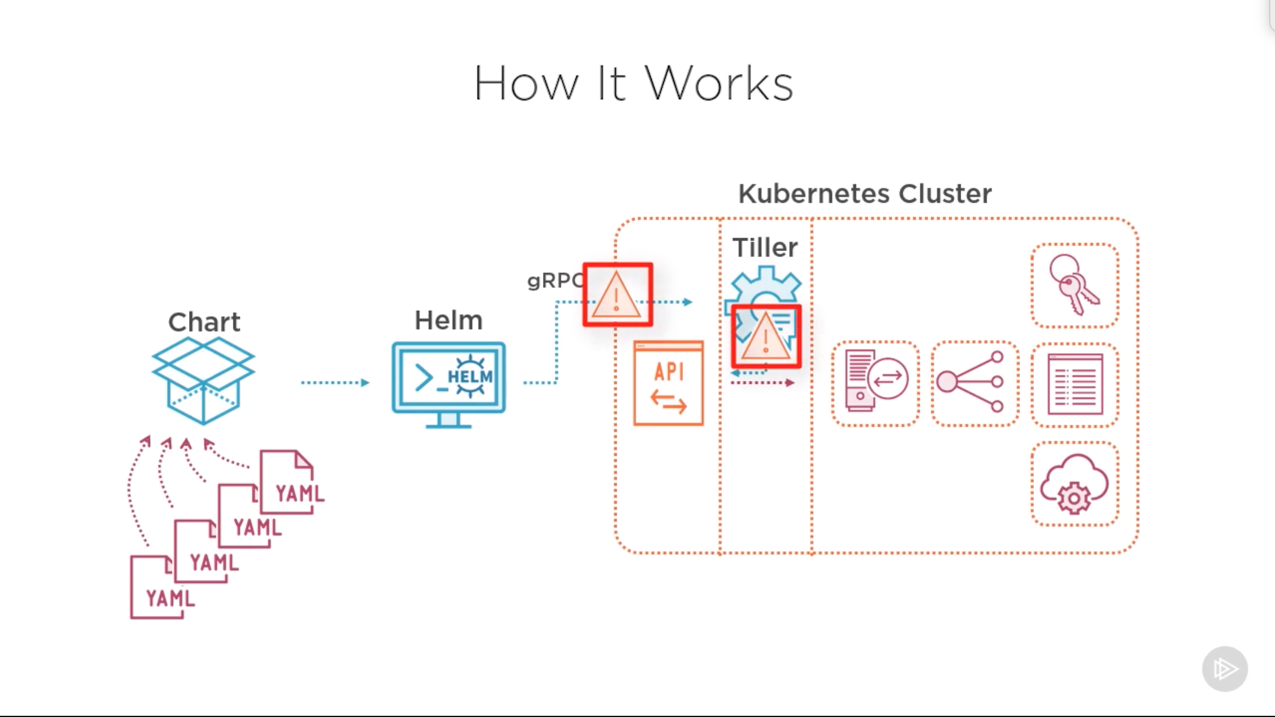

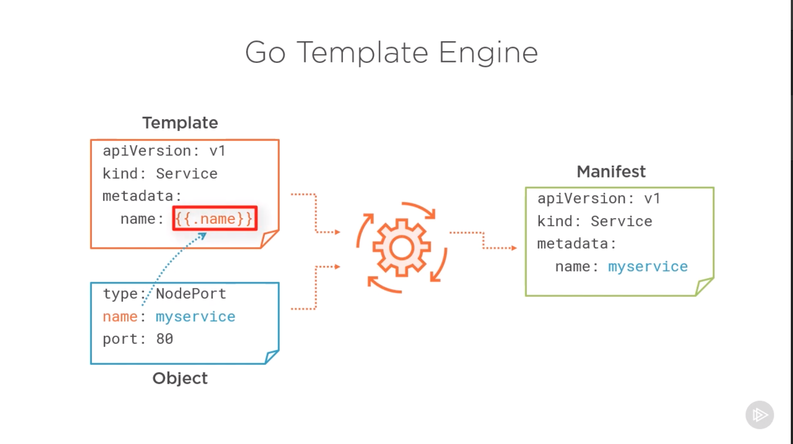

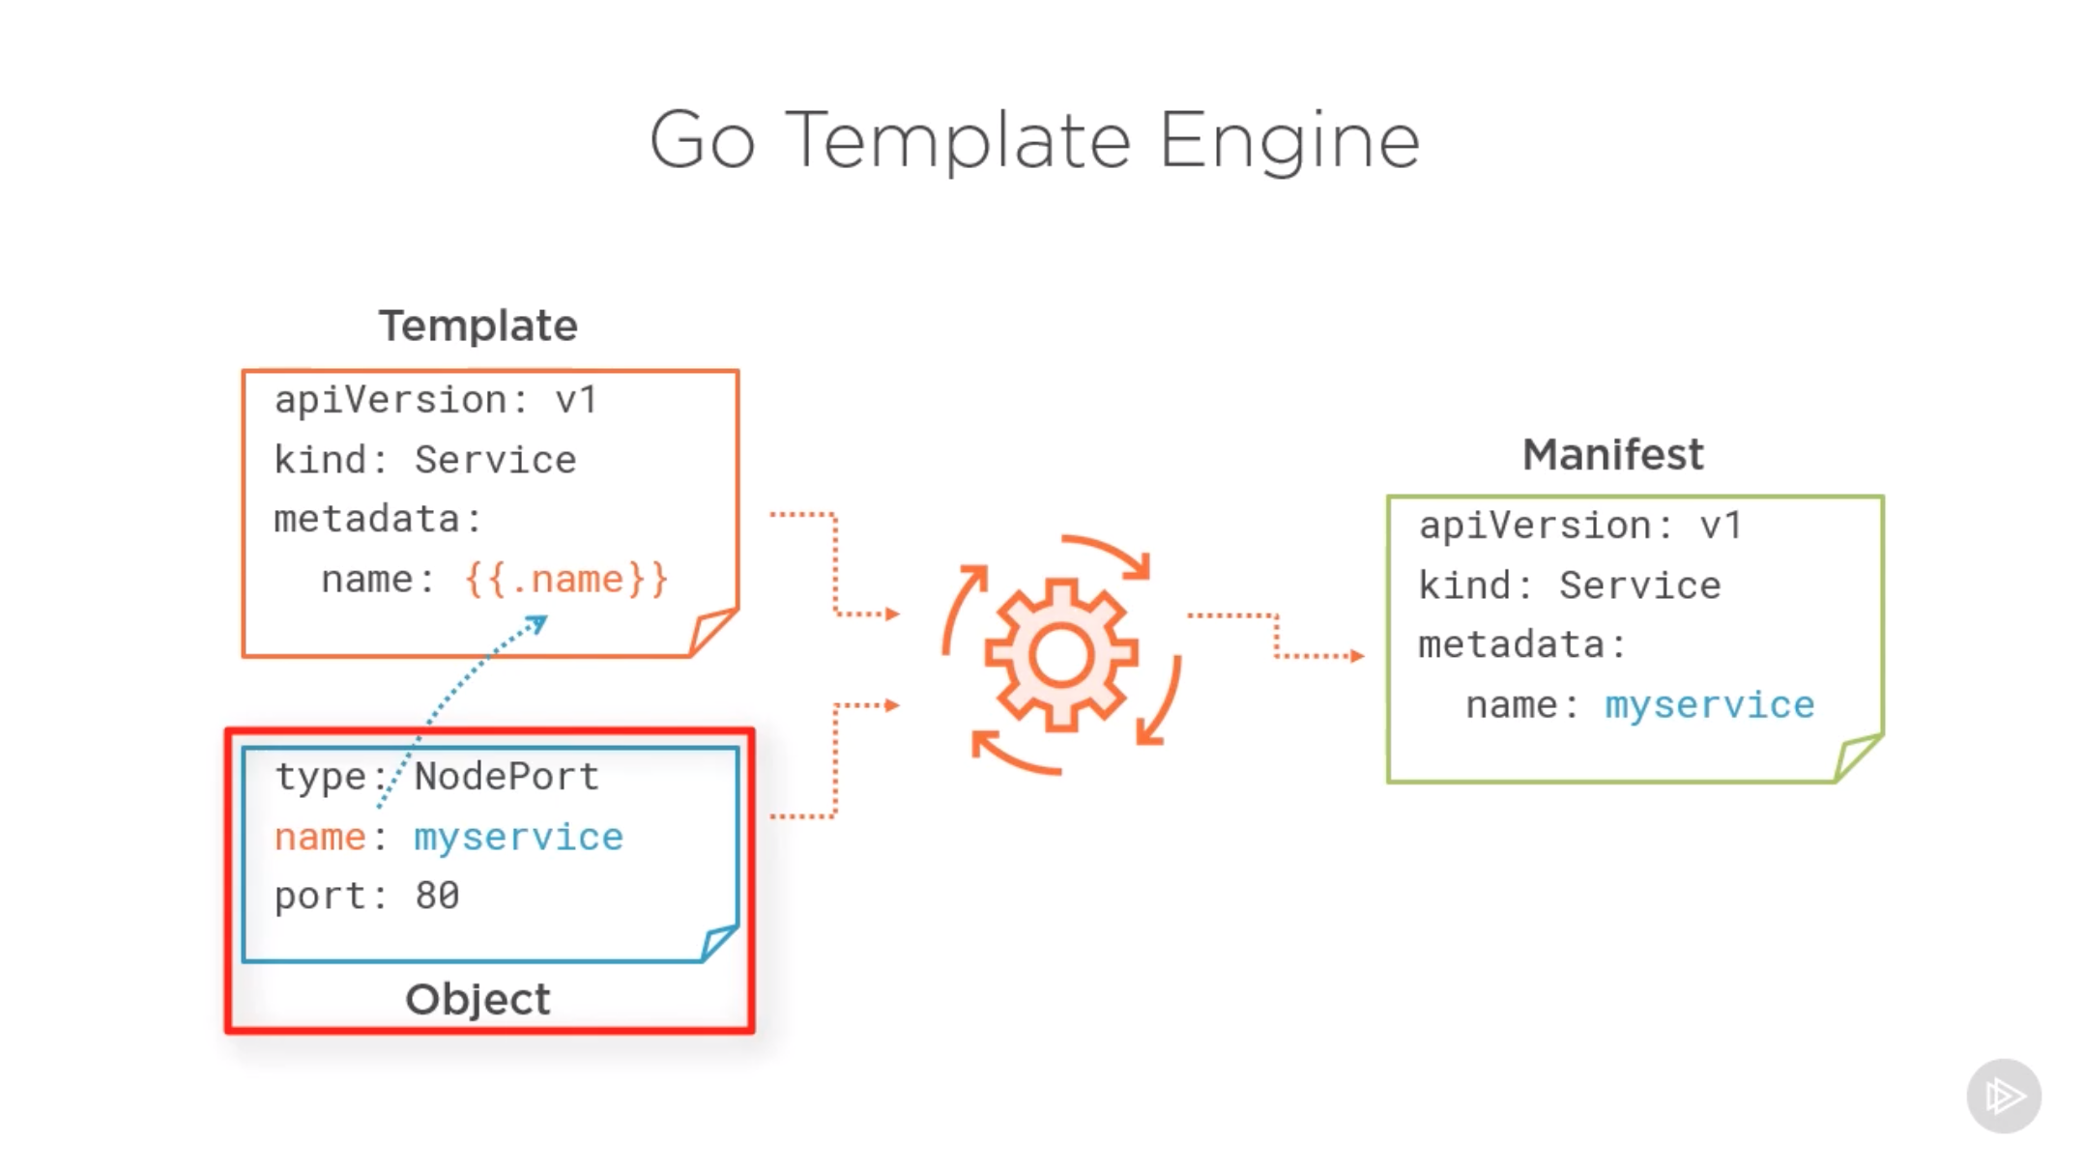

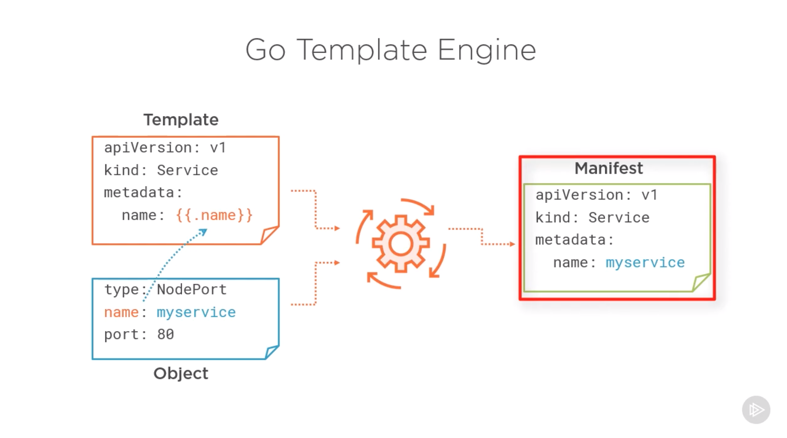

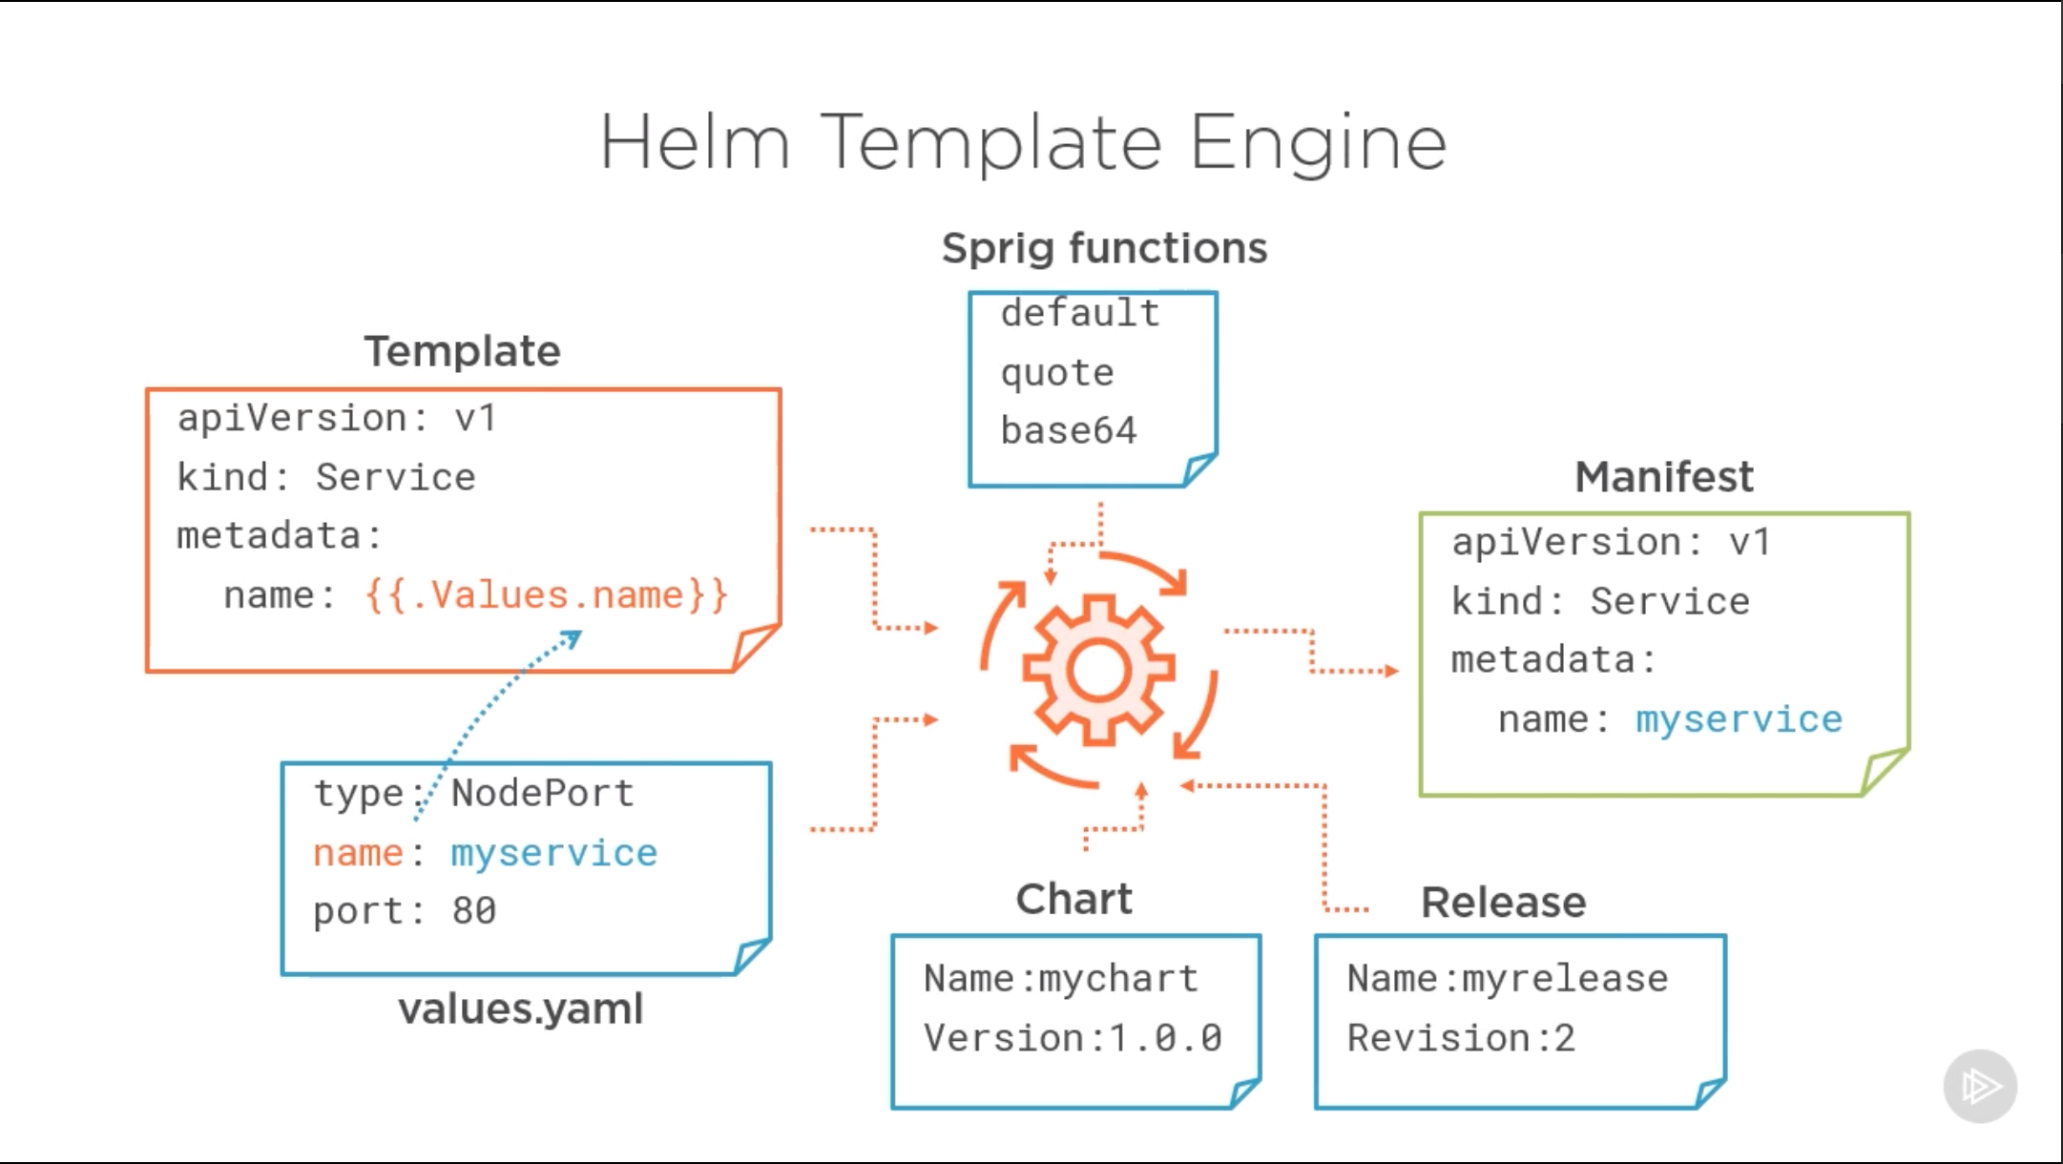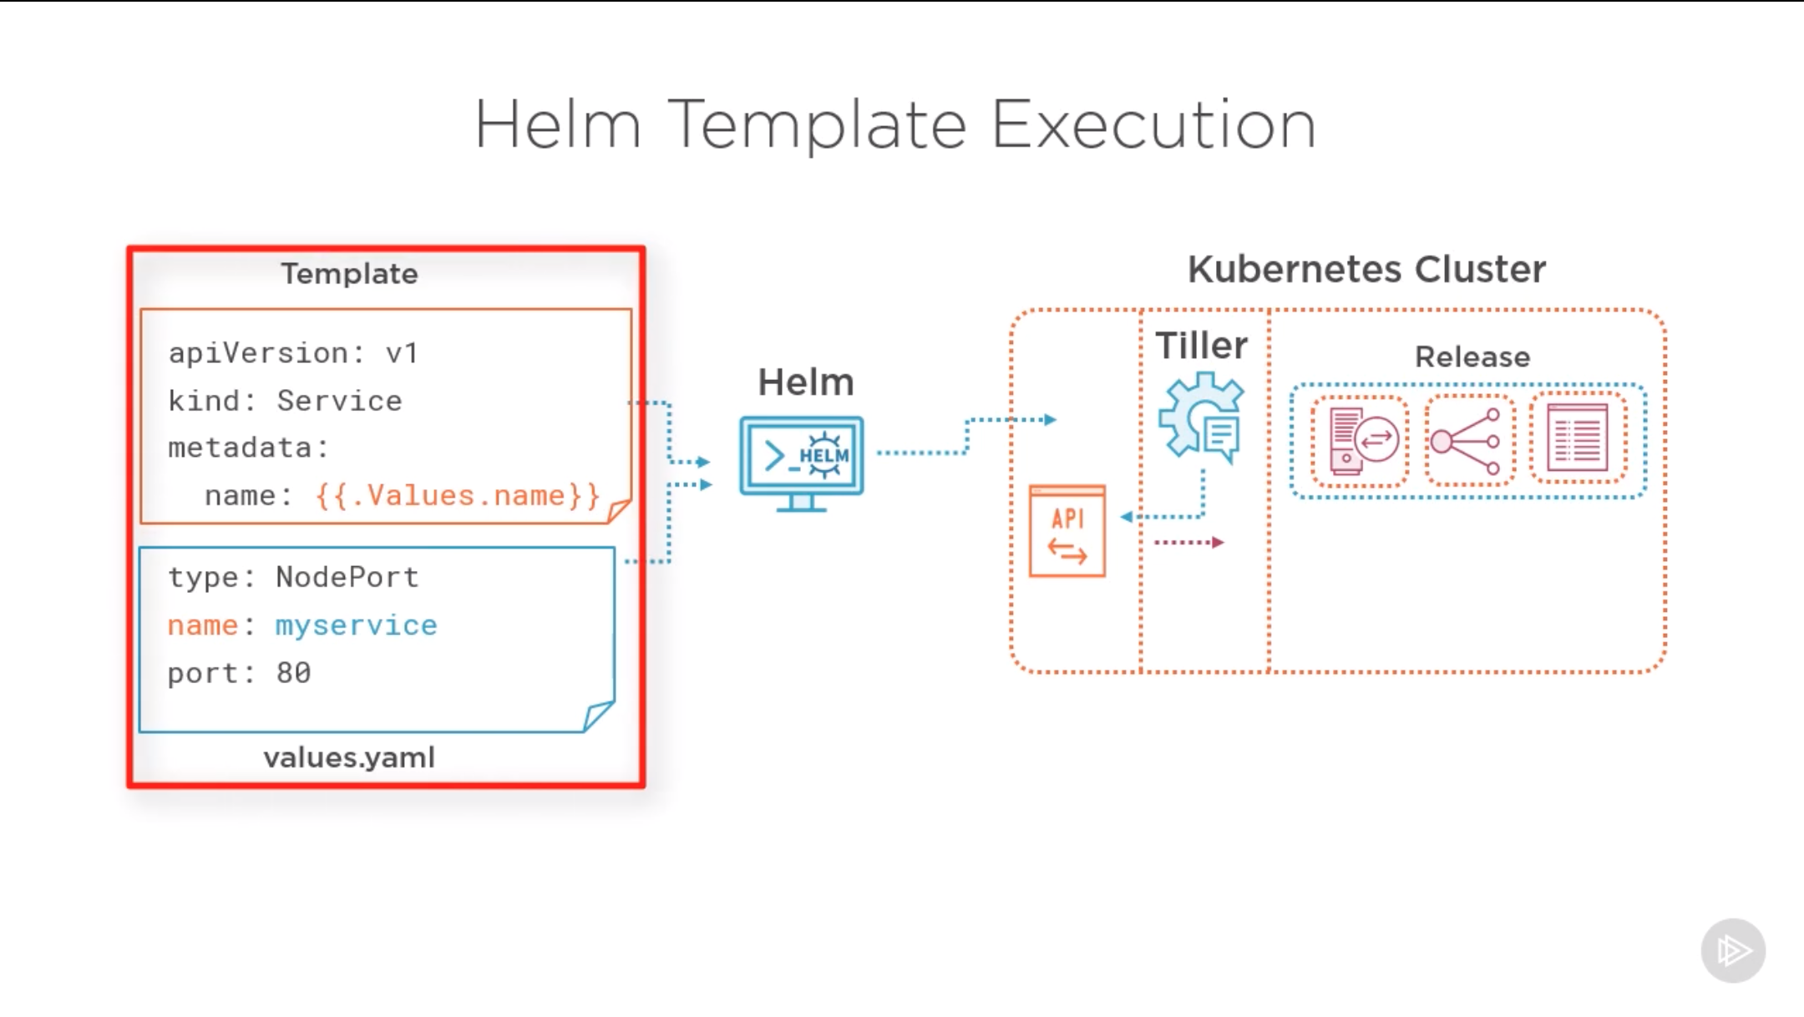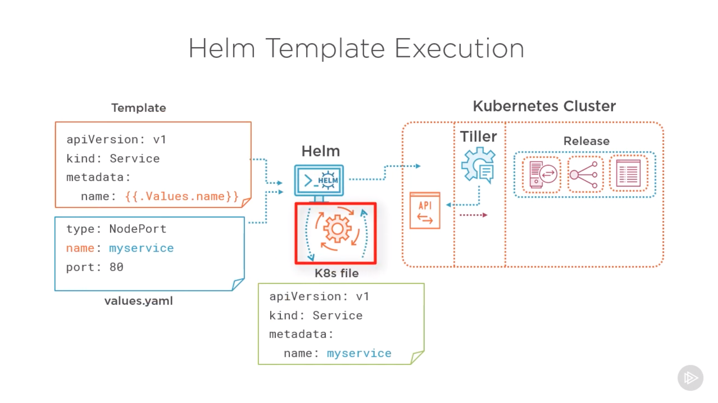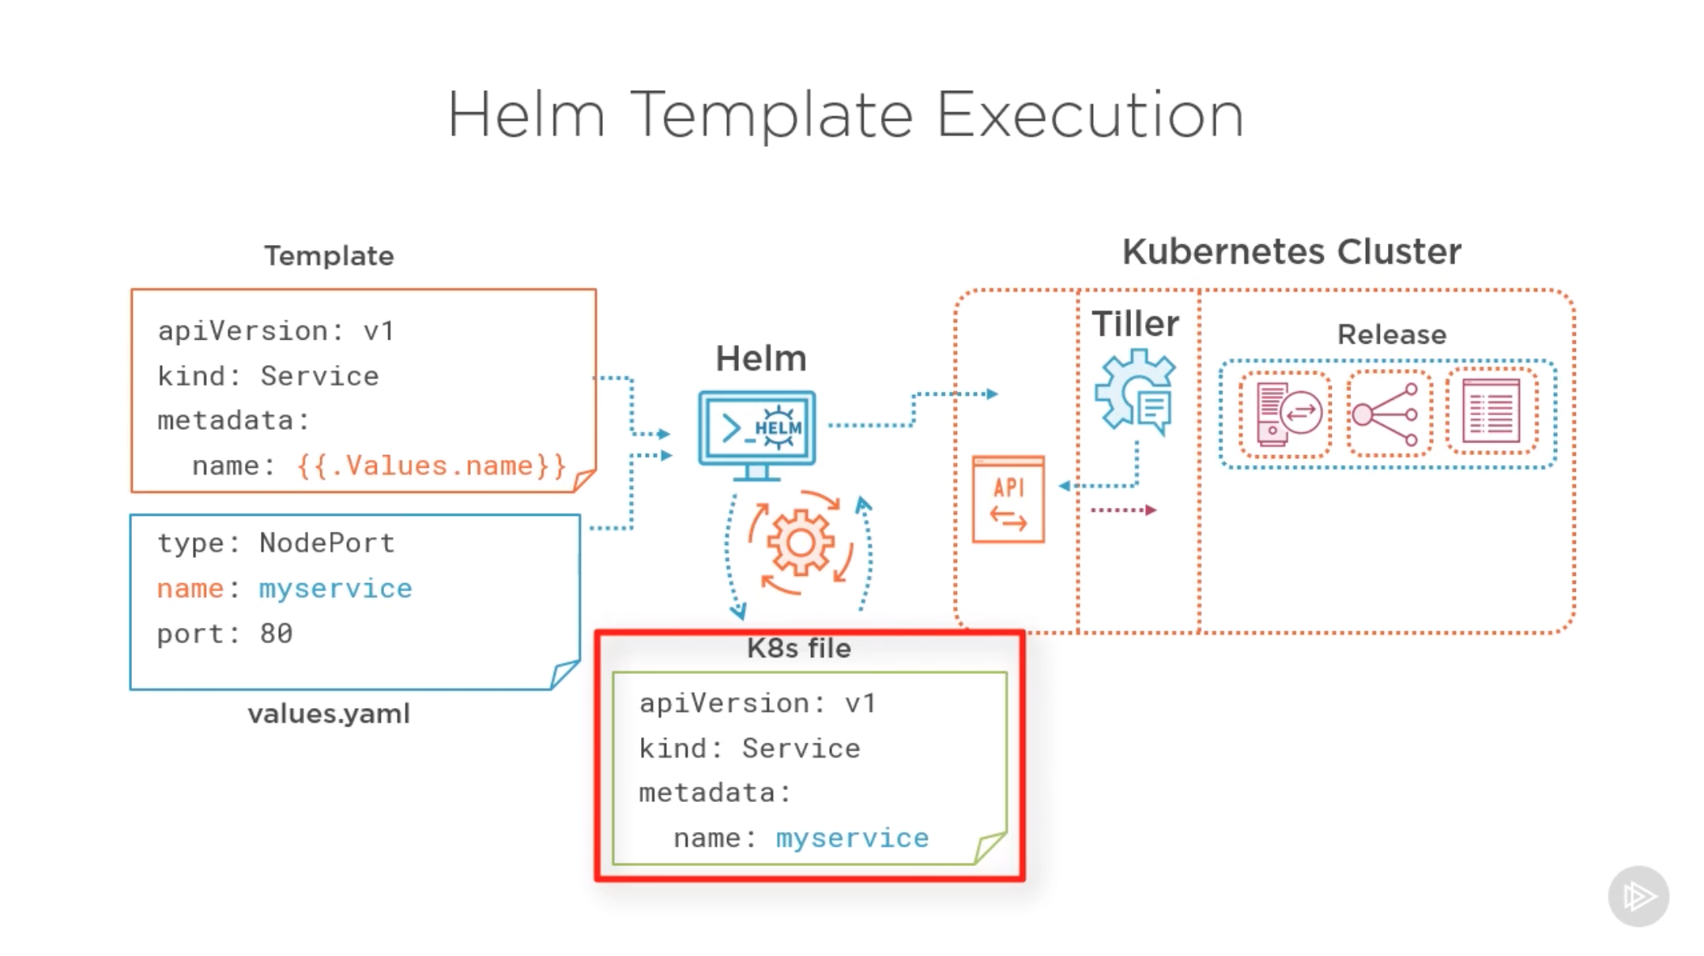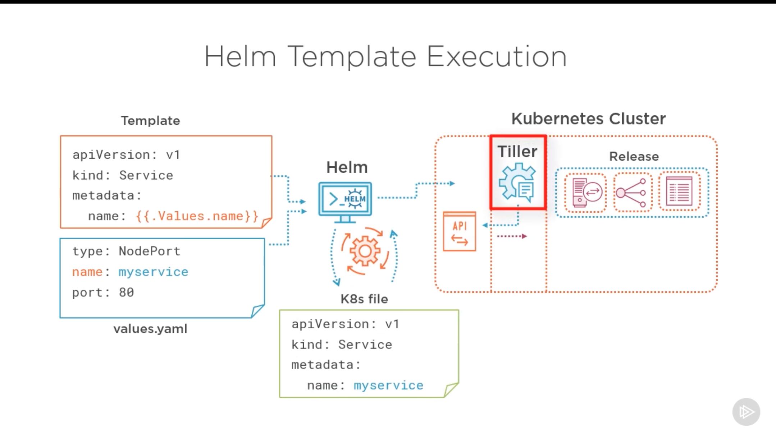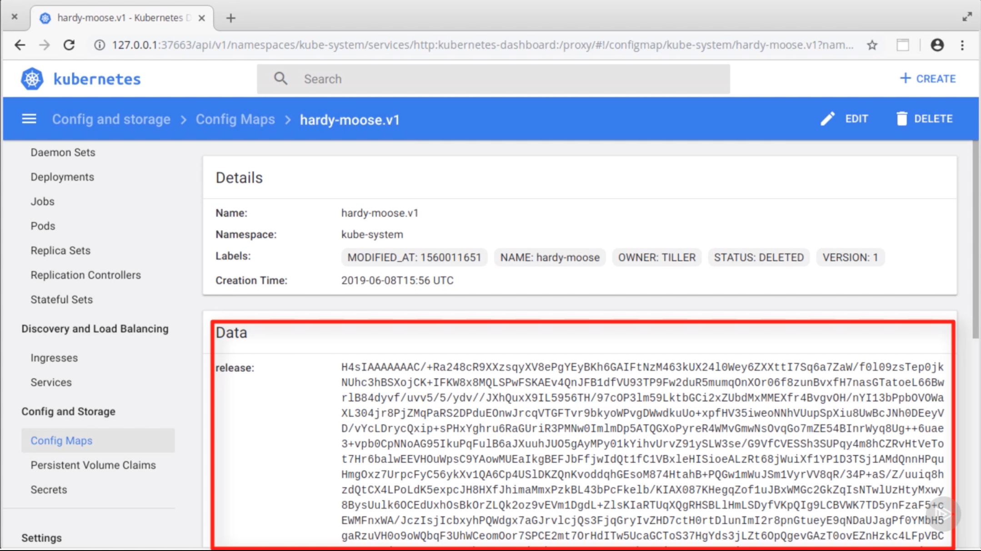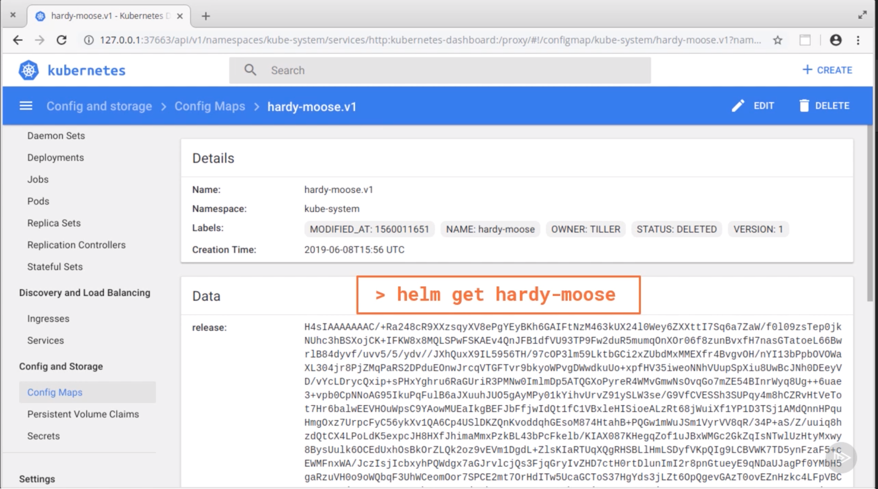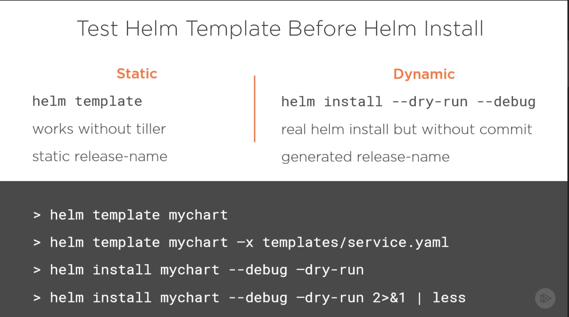

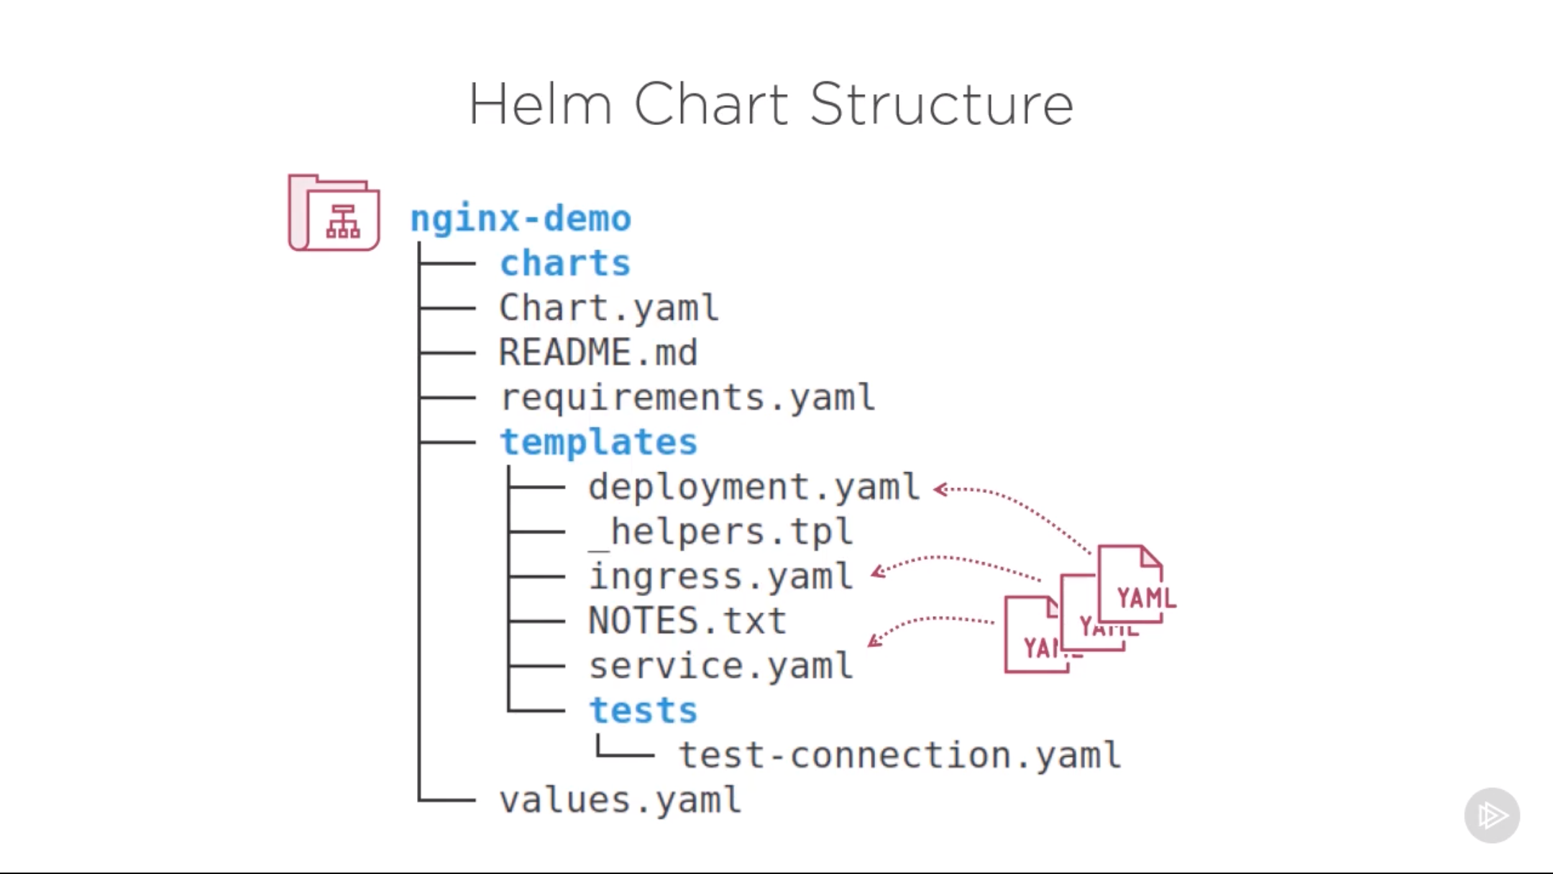

* Helm has two elements, a client (Helm) and a server (Tiller).
* The server element runs inside a Kubernetes cluster and manages the installation of charts. This diagram shows how Helm components are related to each other:

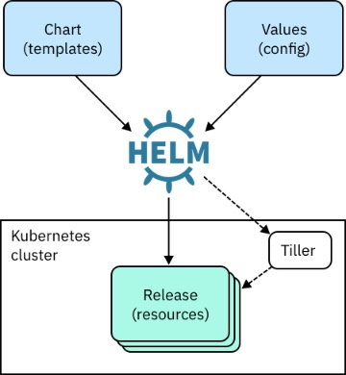

* **Helm**: A command-line interface (CLI) that installs charts into Kubernetes, creating a release for each installation. To find new charts, you search Helm chart repositories.
* **Chart**: An application package that contains *templates* for a set of resources that are necessary to run the application. A template uses variables that are substituted with values when the manifest is created. The chart includes a values file that describes how to configure the resources.
* **Repository**: Storage for Helm charts. The namespace of the hub for official charts is *stable*.
* Release: An instance of a chart that is running in a Kubernetes cluster. You can install the same chart multiple times to create many releases.
* **Tiller**: The Helm server-side templating engine, which runs in a pod in a Kubernetes cluster. Tiller processes a chart to generate Kubernetes resource manifests, which are YAML-formatted files that describe a resource. [YAML](http://yaml.org/start.html) is a human-readable structured data format. Tiller then installs the release into the cluster. Tiller stores each release as a Kubernetes ConfigMap.

**Why use Helm?**

Helm can make deployments easier and repeatable because all resources for an application are deployed by running one command:

$ helm install <chart>

With Helm, configuration settings are kept separate from the manifest formats. You can edit the configuration values without changing the rest of the manifest. Configuration settings are in a values.yaml file. You update the runtime parameters in that file to deploy each application instance differently.

You can use single commands for installing, upgrading, and deleting releases.

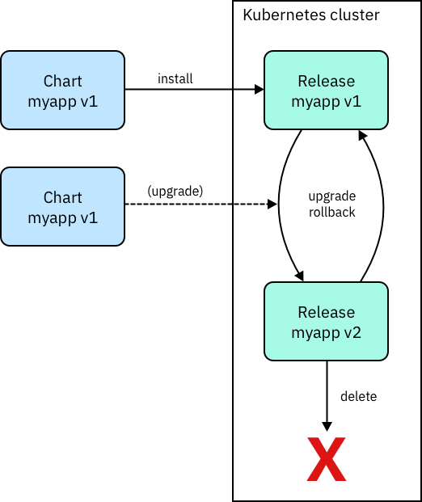

## Installing Helm

## 

Helm runs as a command-line interface (CLI) and is typically installed on your notebook. You have several options for installing Helm:

* Install from an IBM Cloud™ Private image. If you install from the image, you can be sure that you have the correct Helm version to work with the Tiller version that is running in your IBM Cloud Private instance.

For more information, see [Setting up the Helm CLI](https://www.ibm.com/support/knowledgecenter/en/SSBS6K_2.1.0.3/app_center/create_helm_cli.html) in IBM Knowledge Center.

* [Download the release](https://github.com/kubernetes/helm/releases), including the binary.
* Use Homebrew on MacOS:
* brew install kubernetes-helm
* Use an installer script:

curl https://raw.githubusercontent.com/kubernetes/helm/master/scripts/get > get_helm.sh

What is a chart repository?

A chart repository is an HTTP server that houses packaged charts and an index.yaml file. That file has an index of all the charts in the repository. A chart repository can be any HTTP server that can serve YAML and .tar files and can answer GET requests. Therefore, you have many options for hosting your chart repository. You can use a Google Cloud Storage bucket, an Amazon S3 bucket, GitHub pages, or you can create a web server.

In IBM Cloud Private, catalog entries are Helm charts that can be deployed from the chart repositories. To access the Helm charts from the IBM Cloud Private management console, click **Catalog** in the menu, and then click **Helm Charts**.

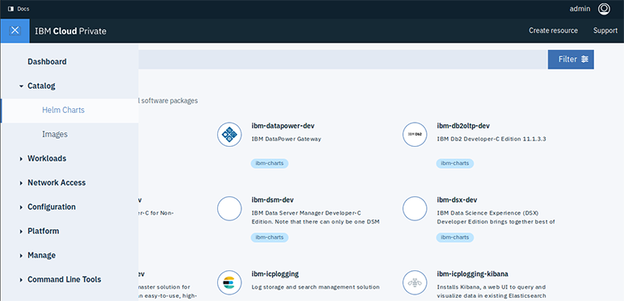

Click to expand the image

This example shows IBM Cloud Private catalog entries, including the ibm-calico-bgp-peer Helm chart:

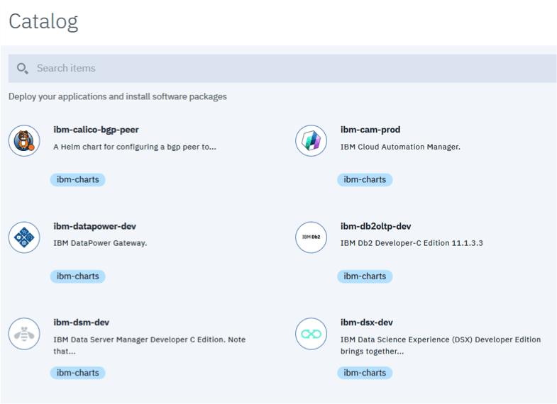

Click to expand the image

Details about the chart are shown here:

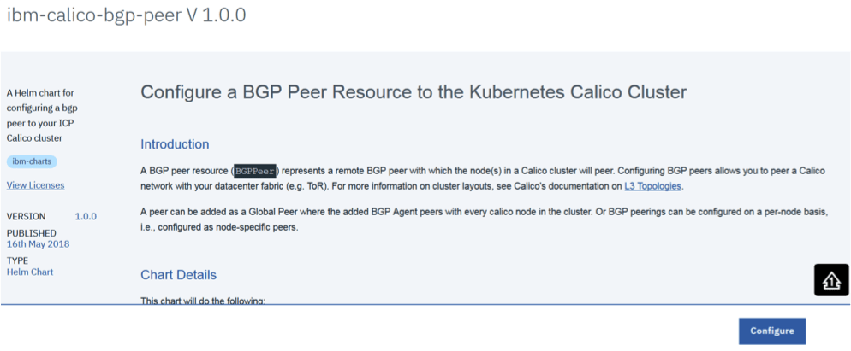

Click to expand the image

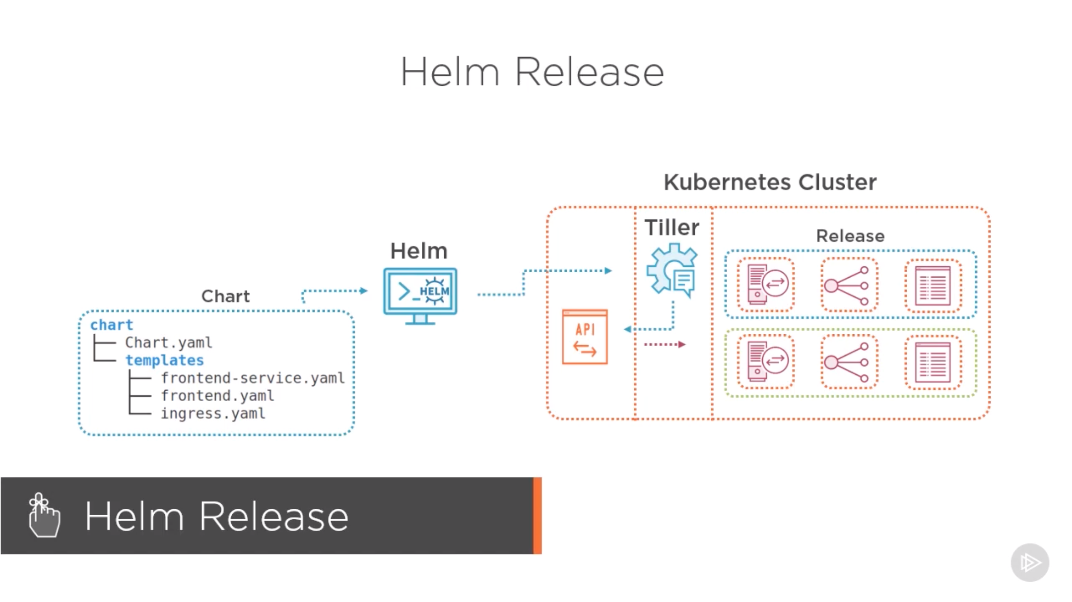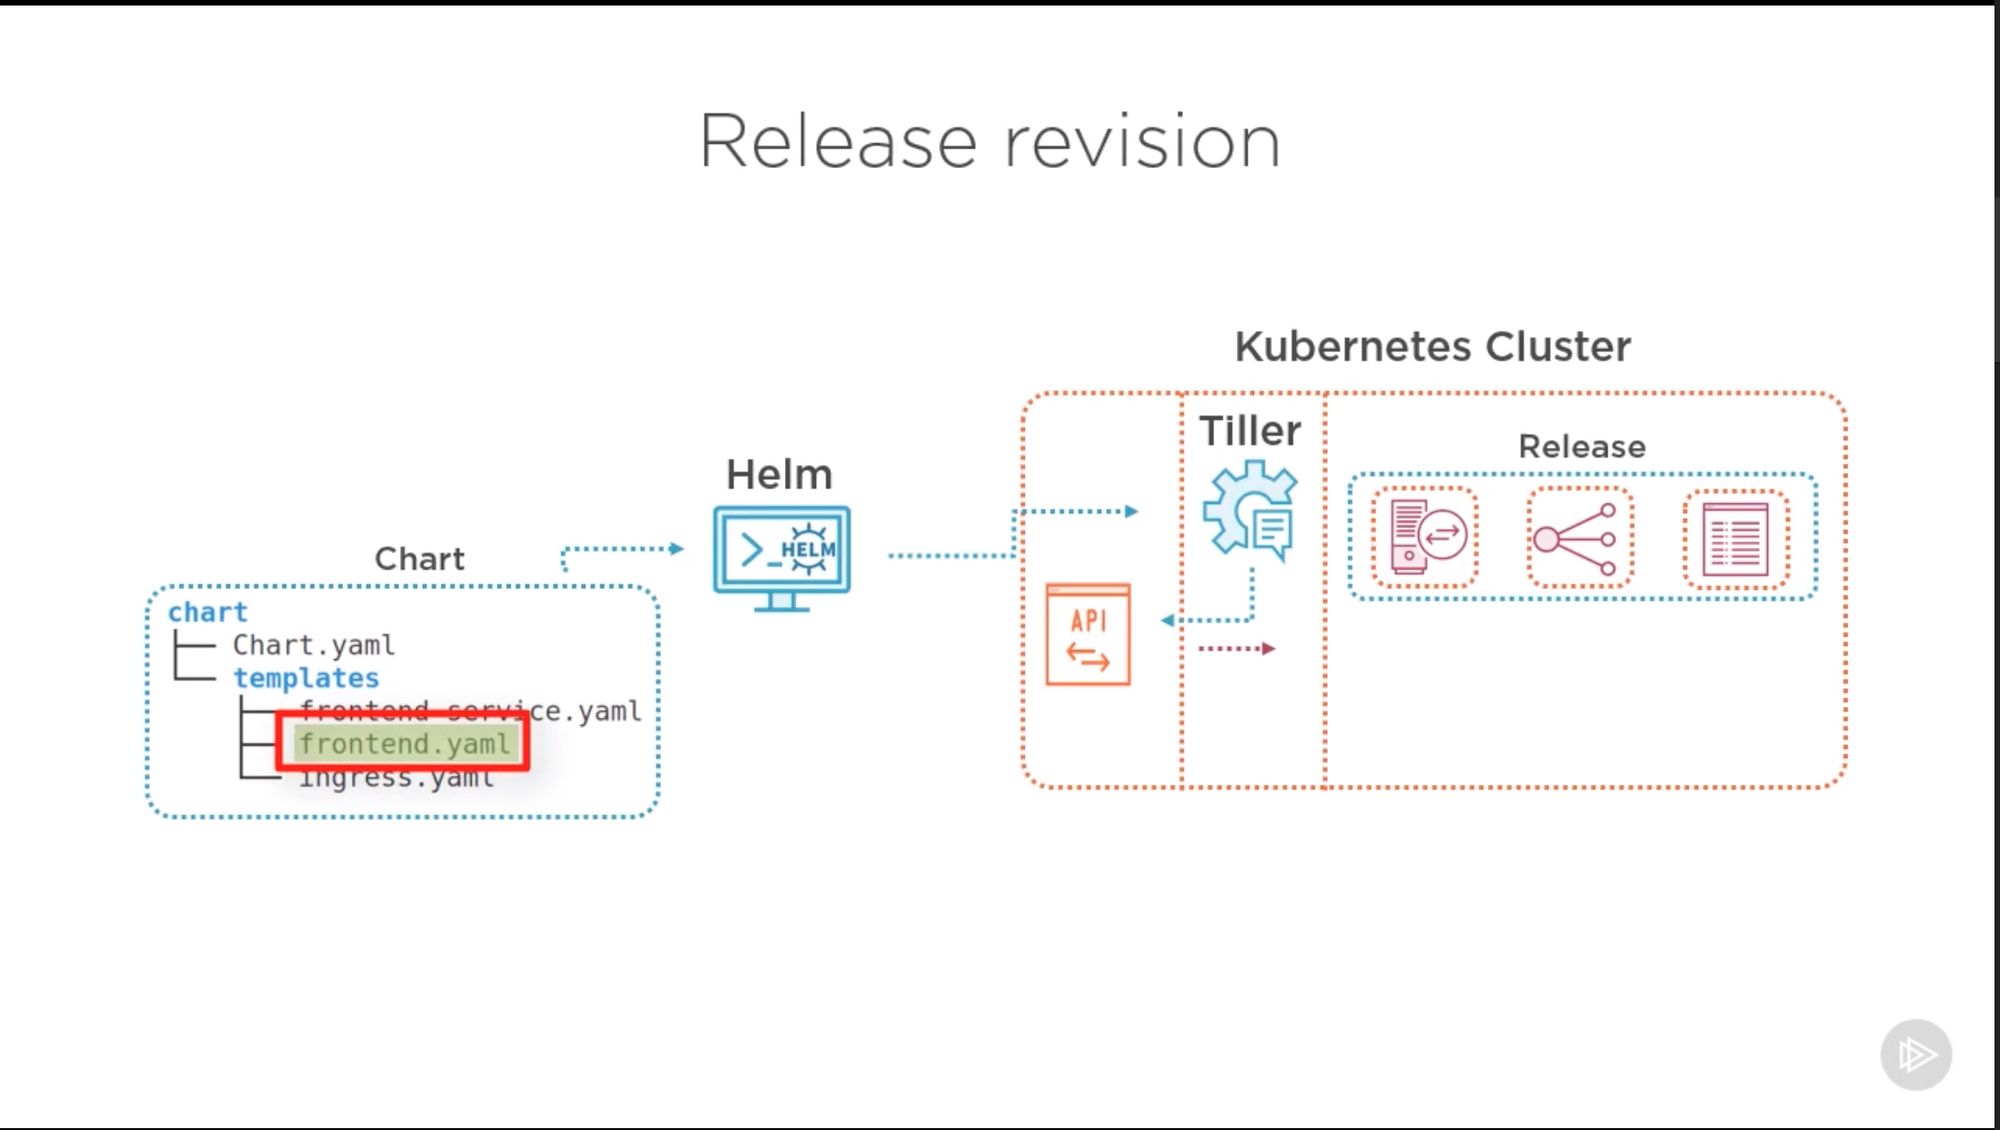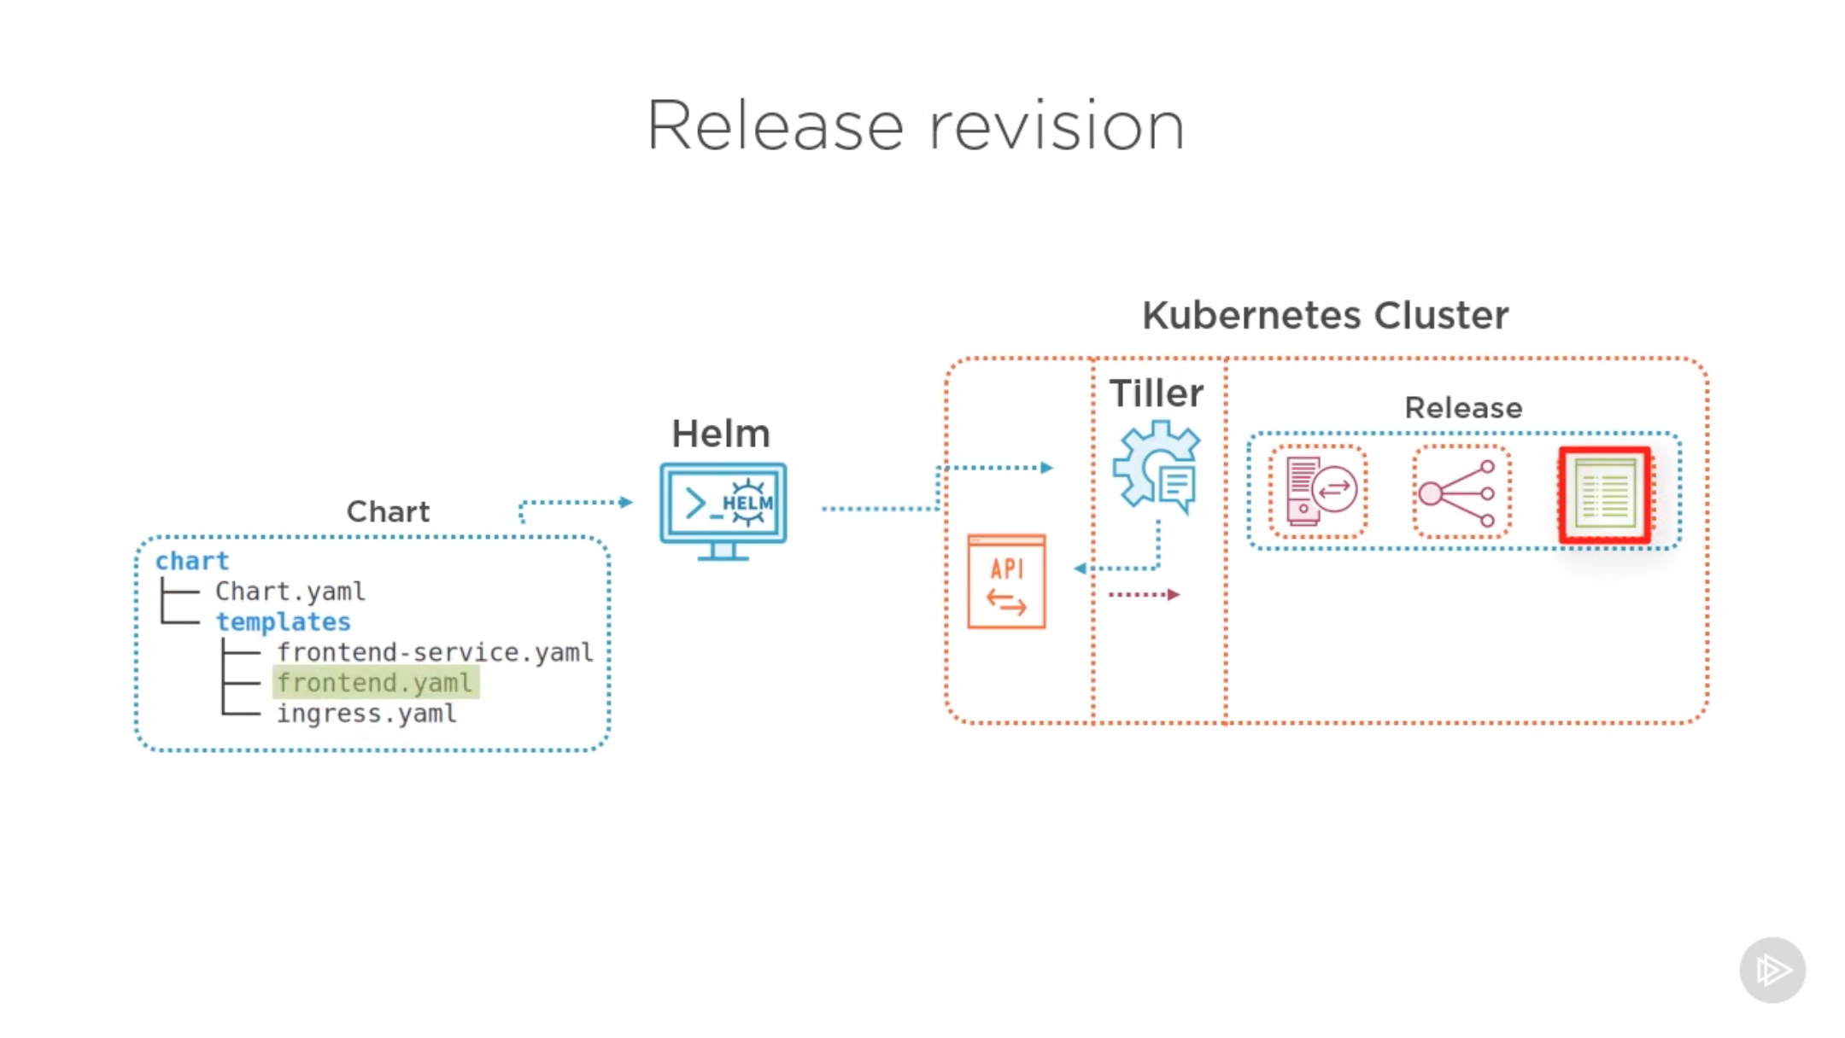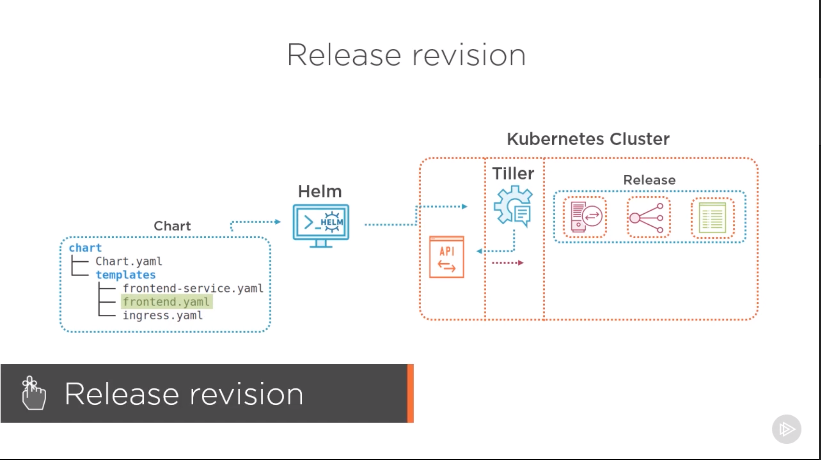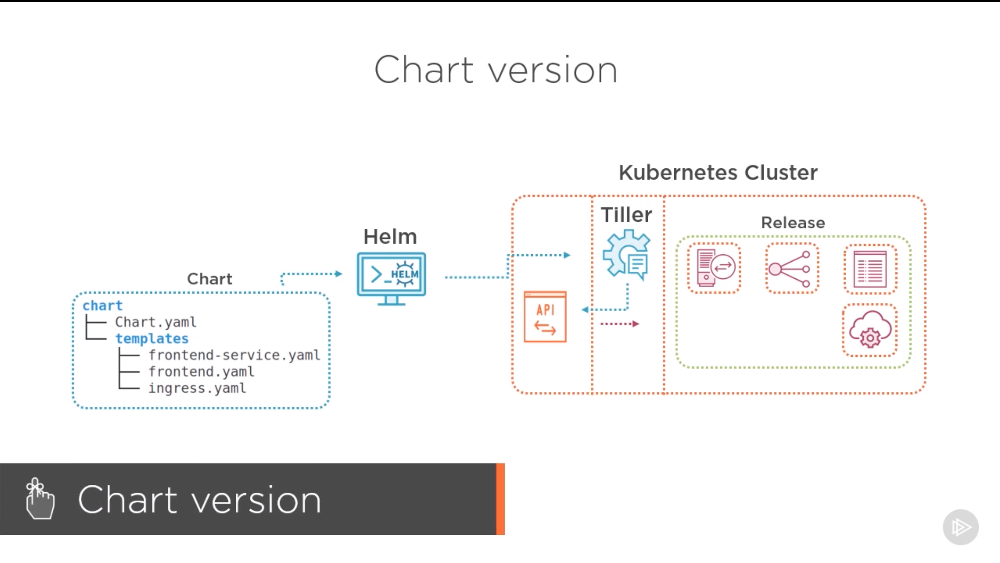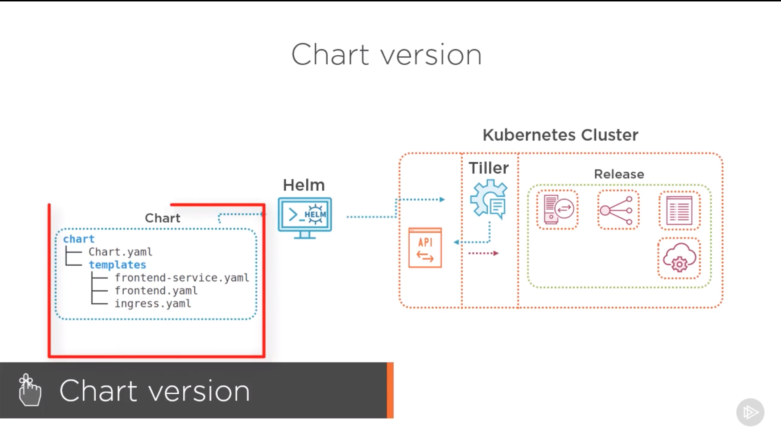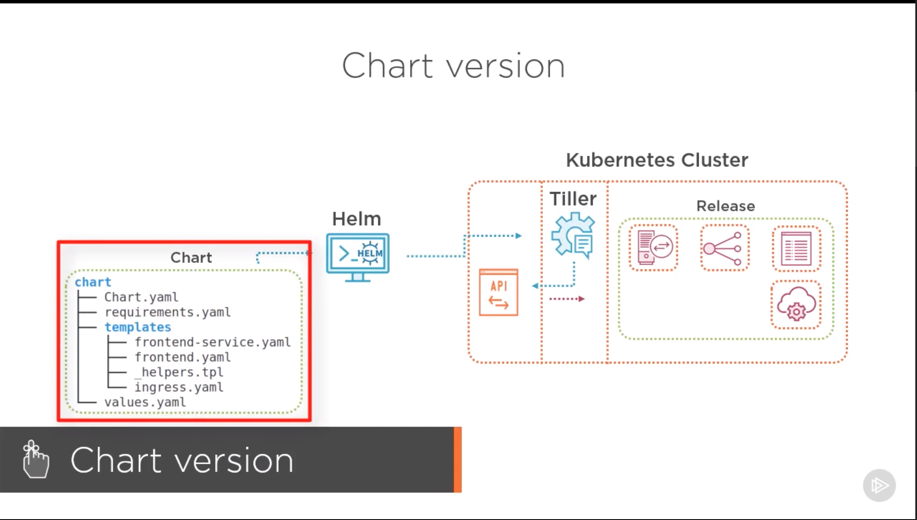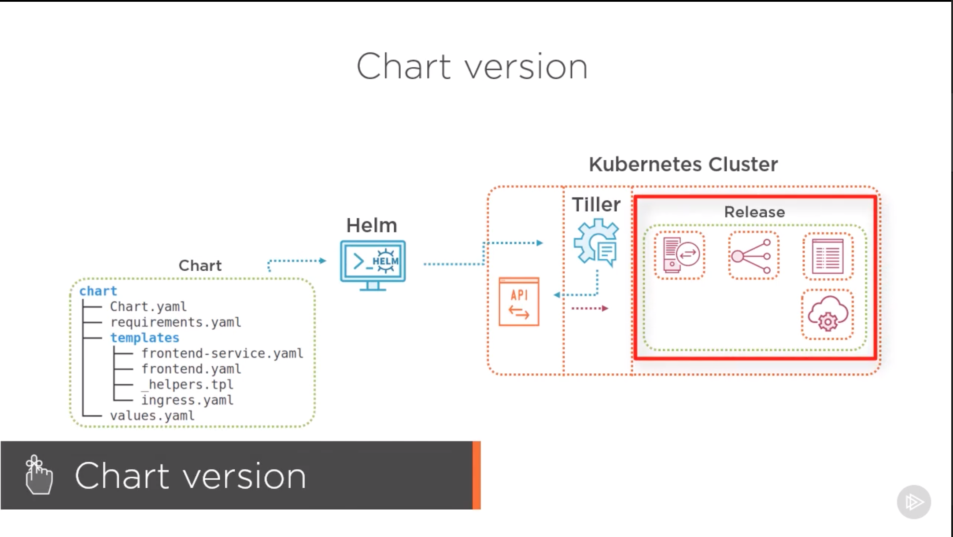

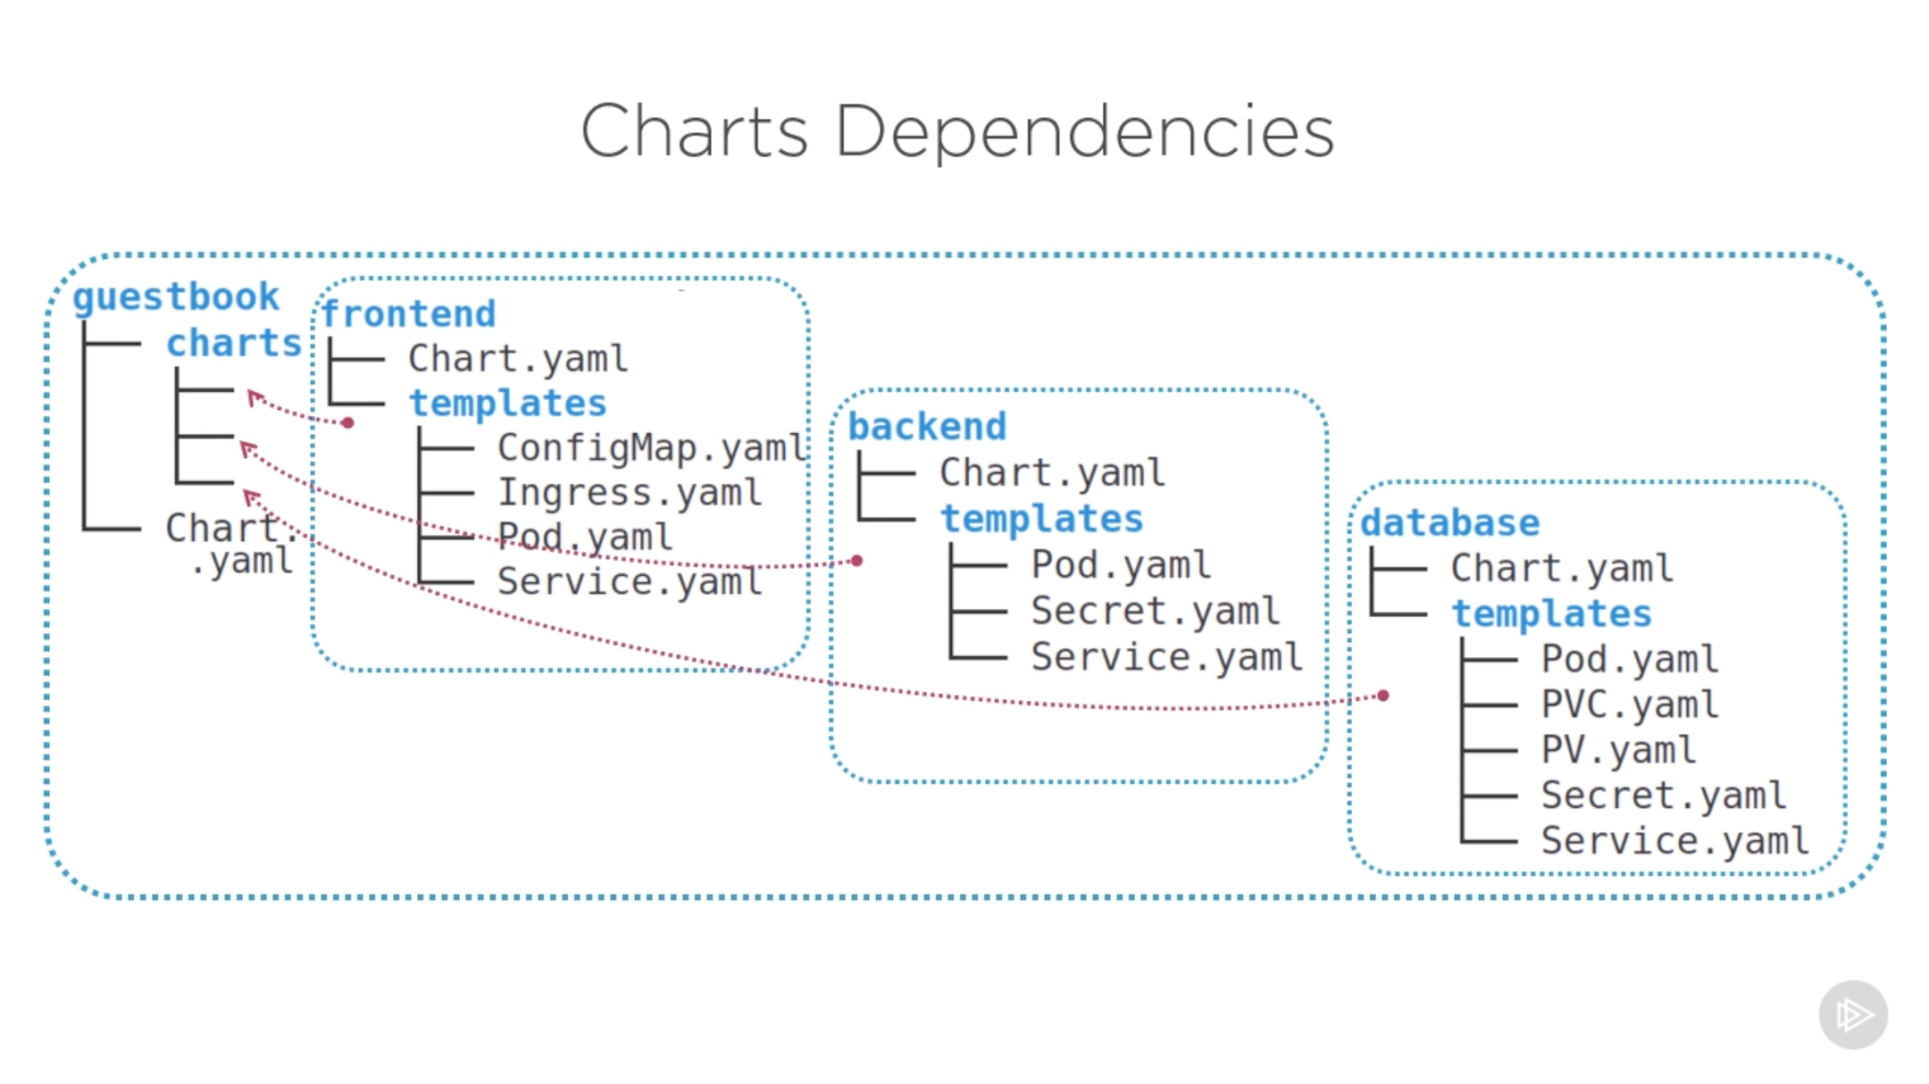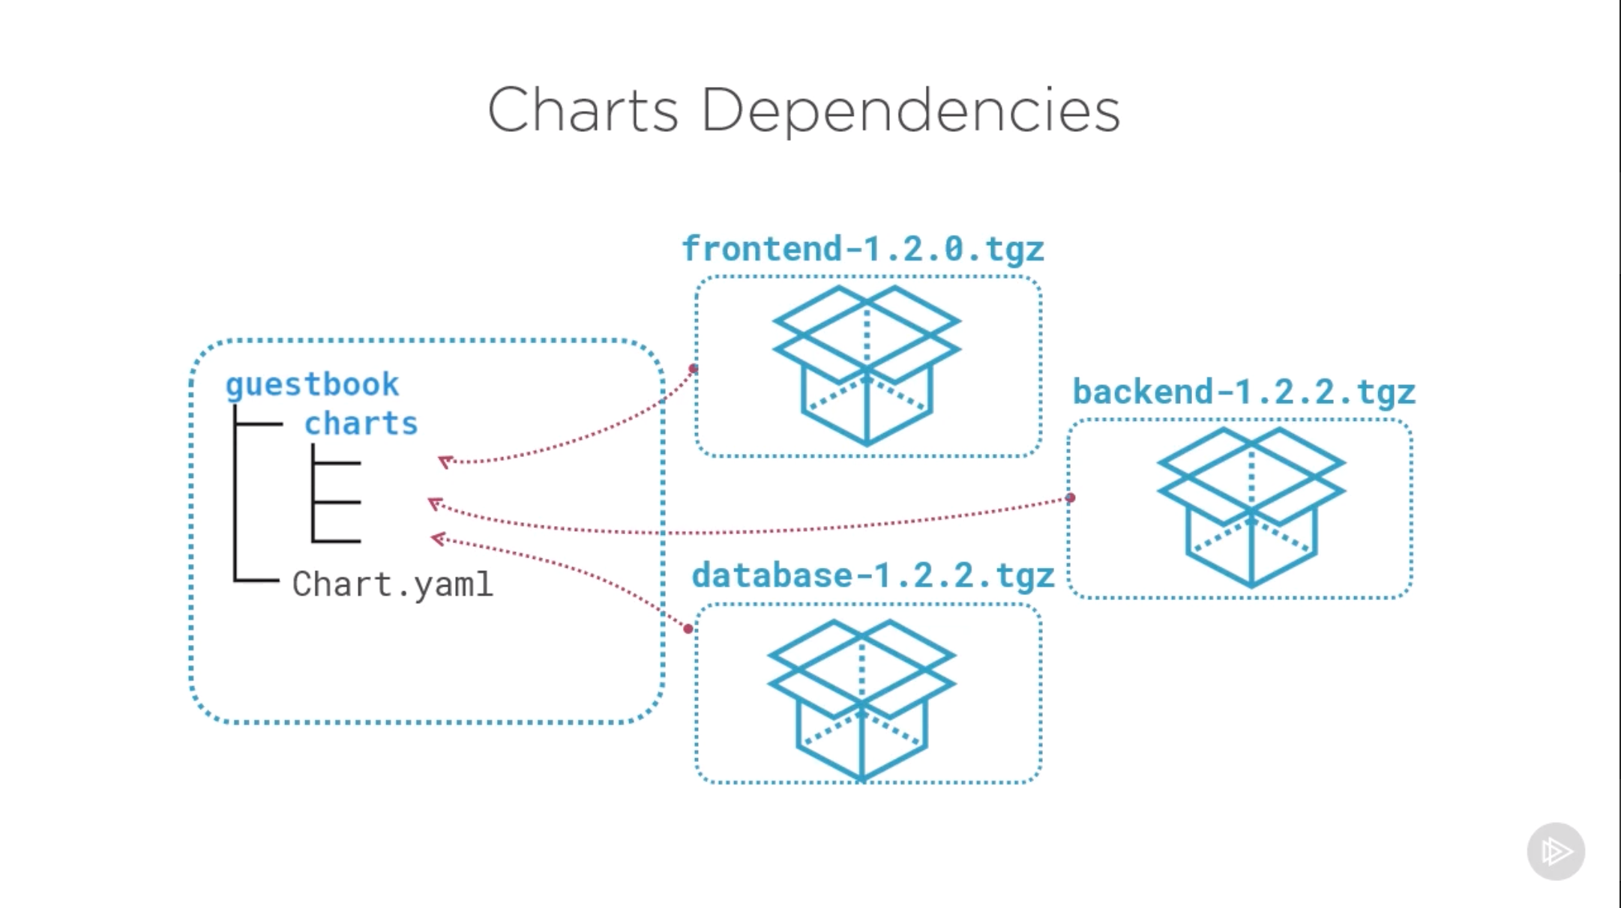

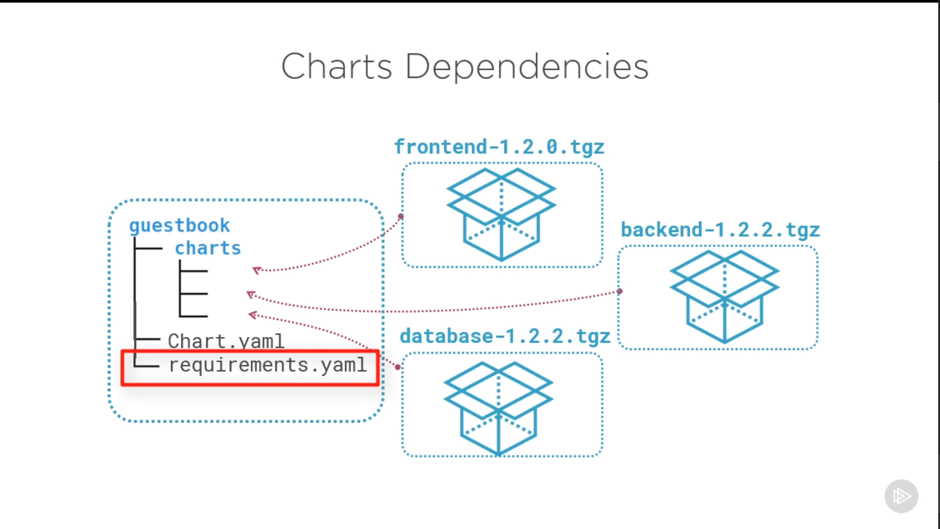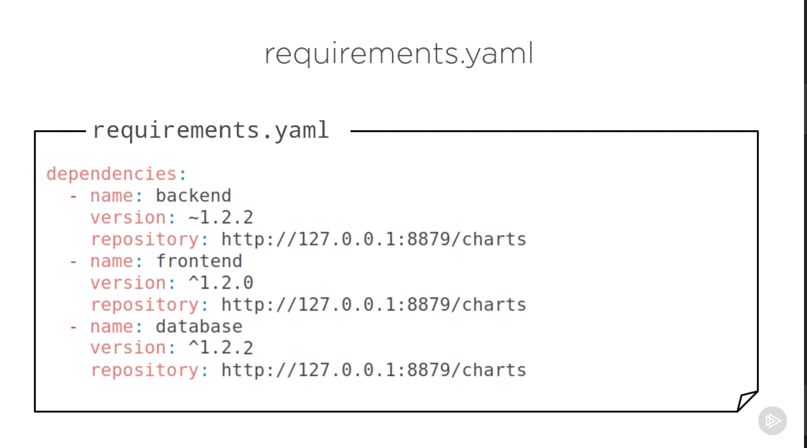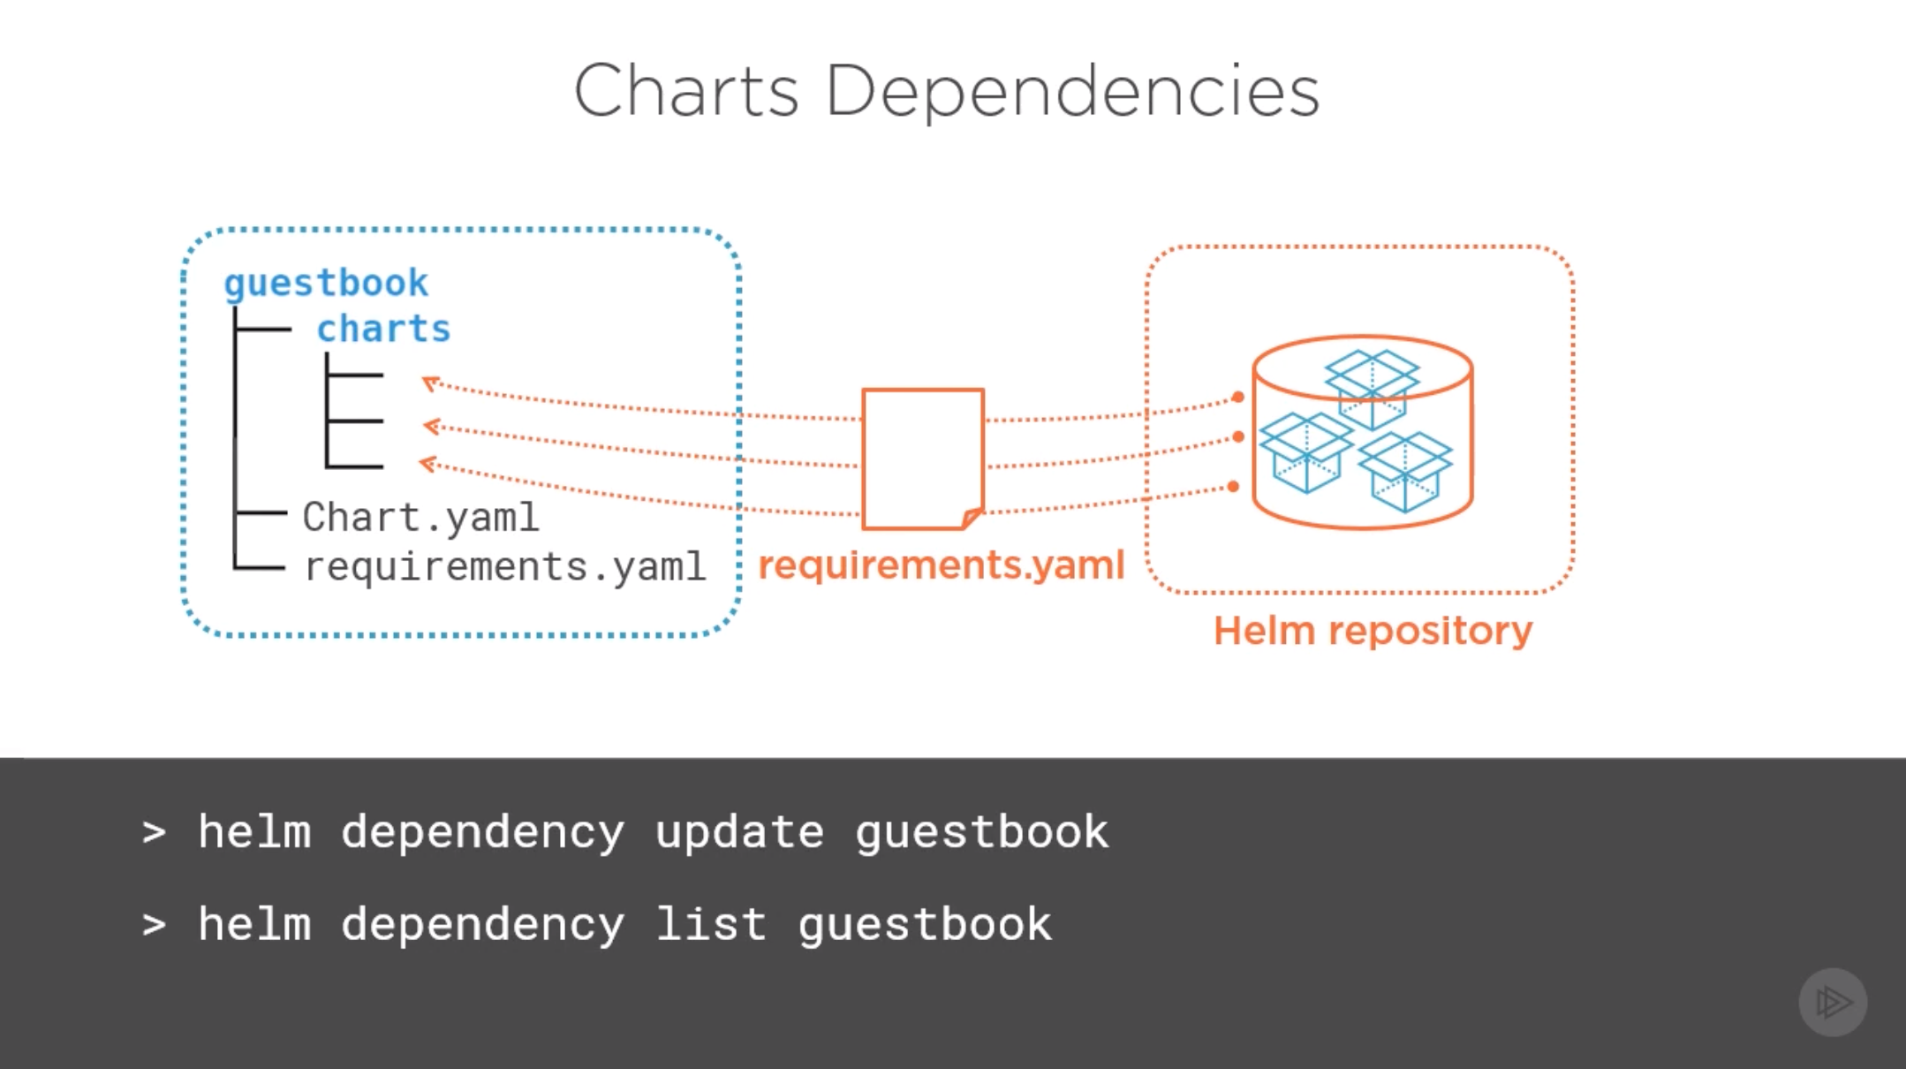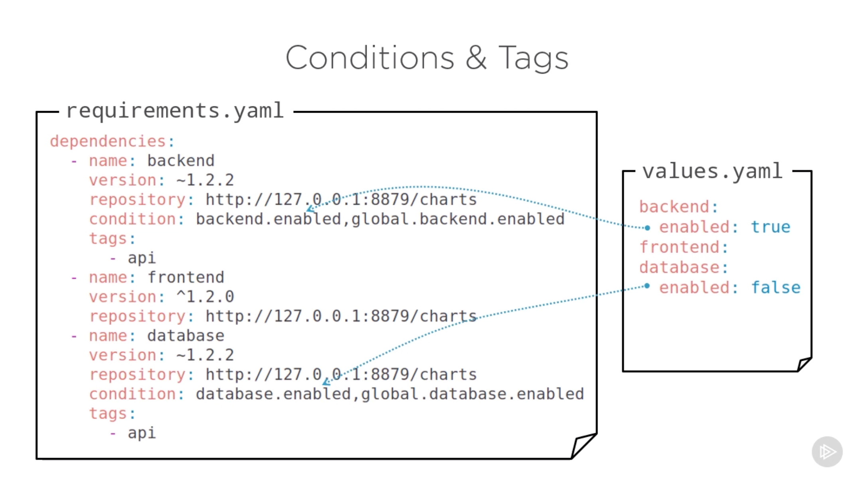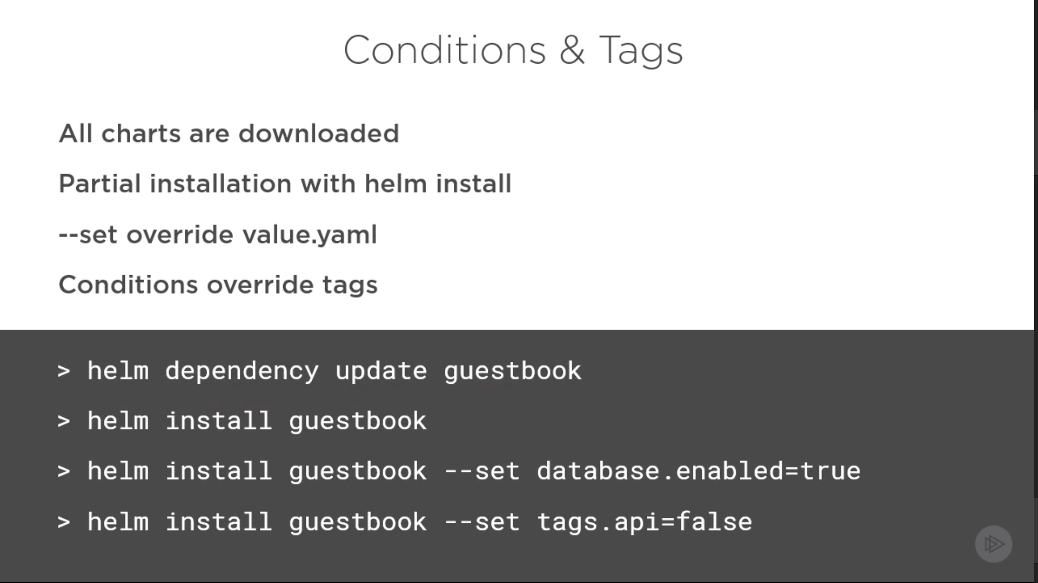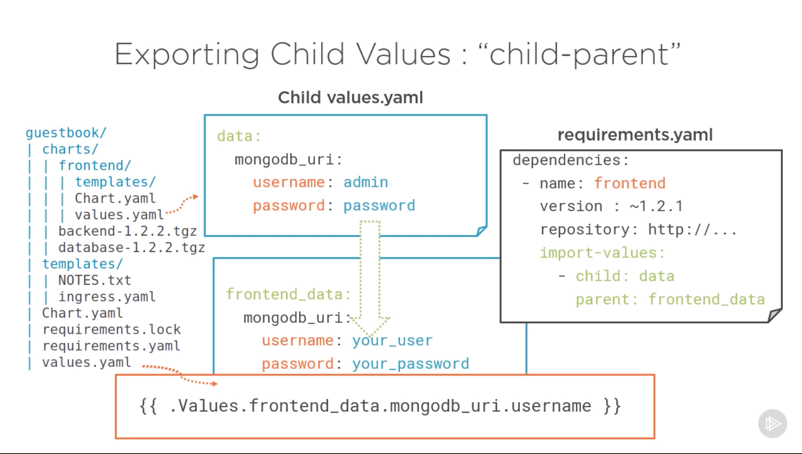

**Commands for working with repositories**

$ helm repo list

NAME URL

stable https://kubernetes-charts.storage.googleapis.com/

$ helm search jenkins

NAME VERSION DESCRIPTION

stable/jenkins 0.1.14 A Jenkins Helm chart for Kubernetes.

$ helm repo add my-charts https://my-charts.storage.googleapis.com

$ helm repo list

NAME URL

stable https://kubernetes-charts.storage.googleapis.com/

my-charts https://my-charts.storage.googleapis.com

## Deploying an application

The Helm install command deploys an application. The command output includes details about the release and resources. For the chart in this example, stable/mysql, the release name is loping-toad. One resource of each type exists, all named loping-toad-mysql:

* Secret
* Service
* Deployment
* PersistentVolumeClaim

$ helm search mysql

NAME VERSION DESCRIPTION

stable/mysql 0.1.1 Chart for MySQL

$ helm install stable/mysql

Fetched stable/mysql to mysql-0.1.1.tgz

NAME: loping-toad

LAST DEPLOYED: Thu Oct 20 14:54:24 2016

NAMESPACE: default

STATUS: DEPLOYED

RESOURCES:

==> v1/Secret

NAME TYPE DATA AGE

loping-toad-mysql Opaque 2 3s

==> v1/Service

NAME CLUSTER-IP EXTERNAL-IP PORT(S) AGE

loping-toad-mysql 192.168.1.5 <none> 3306/TCP 3s

==> extensions/Deployment

NAME DESIRED CURRENT UP-TO-DATE AVAILABLE AGE

loping-toad-mysql 1 0 0 0 3s

==> v1/PersistentVolumeClaim

NAME STATUS VOLUME CAPACITY ACCESSMODES AGE

loping-toad-mysql Pending

## Default and custom deployment values

The default values for a deployment are stored in the values.yaml file in the chart. You can customize aspects of the deployment by overriding those values.

First, the Helm CLI uses the Kubernetes CLI's configuration to connect to your current cluster.

~/.kube/config

$ kubectl config view

After it connects to your cluster, you use Helm installation commands to specify the attributes of the release.

* To specify a release's name, use the --name flag  
  :
* $ helm install --name CustomerDB stable/mysql
* To deploy the release into a Kubernetes namespace, use the --namespace flag:
* $ helm install --namespace ordering-system stable/mysql
* To override a value, use the --set flag  
  :
* $ helm install --set user.name='student',user.password='passw0rd' stable/mysql
* To override values with a values file, use the --values or the --f flag  
  :

$ helm install --values myvalues.yaml stable/mysql

## Helm command reference

## 

Helm provides many commands for managing charts and Helm repositories. This list shows examples of the more common commands. After you configure a connection, you must add the --tls option to Helm commands that access the server through Tiller.

* Install Tiller:
* $ helm init
* Create a chart:
* $ helm create <chart>
* List the repositories:
* $ helm repo list
* Search for a chart:
* $ helm search <keyword>
* Get information about a chart:
* $ helm inspect <chart>
* Deploy a chart (creates a release):
* $ helm install <chart>
* List all releases:
* $ helm list --all
* Get the status of a release:
* $ helm status <release>
* Get the details about a release:
* $ helm get <release>
* Upgrade a release:
* $ helm upgrade <release> <chart>
* Roll back a release:
* $ helm rollback <release> <revision>
* Delete a release:

$ helm delete <release>

## Charts and the chart lifecycle

The Helm create command generates a chart with sample files. By default, a chart starts with sample templates for a Kubernetes deployment and service. In the simplest case, you edit the values.yaml file to modify the default configuration for your application.

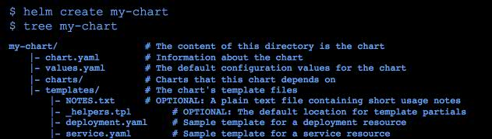

Click to expand the image

**After you run an installation command in the Helm CLI, these actions occur:**

1. Helm CLI loads the chart into Tiller.
2. Tiller renders the chart templates.

Each template generates a Kubernetes resource manifest file (YAML). Tiller runs each of the template files, generating the resource files. Tiller then loads the resources as described by the manifests into the Kubernetes cluster.

1. Tiller loads the resulting resources into Kubernetes.
2. Tiller returns the release data to the client.
3. The client exits.

### Chart lifecycle hooks

Throughout the steps in the chart lifecycle, you can specify hooks, which are predefined actions to be run at specific times. Hooks can be any Kubernetes resource, often a Kubernetes job. Hooks are in the templates directory of the chart.

For example, Tiller runs preinstall hooks before step 2 of the lifecycle and post-install hooks after step 2. The lifecycle hooks for Helm are as follows:

* Preinstall hooks run after templates are rendered and before any resources are created in Kubernetes.
* Post-install hooks run after all resources are loaded into Kubernetes.
* Pre-delete hooks run before any resources are deleted from Kubernetes.
* Post-delete hooks run after all the release’s resources are deleted.
* Pre-upgrade hooks run after templates are rendered and before any resources are loaded into Kubernetes.
* Post-upgrade hooks run after all resources are upgraded.
* Pre-rollback hooks run after templates are rendered and before any resources are rolled back.
* Post-rollback hooks run after all resources are modified.

## Packaging charts

A chart is a directory. A Helm client can use chart directories on the same computer, but it's difficult to share with other users on other computers.

You package a chart by bundling the chart.yaml and related files into a .tar file and then installing the chart into a chart file:

$ helm package <chart-path>

$ helm install <chart-name>.tgz

To add a chart to a repository, copy it to the directory and regenerate the index  
:

$ helm repo index <charts-path> # Generates index of the charts in the repo

## Templates and settings files

Creating a chart consists of implementing a template and populating a settings file, which is the configuration file that the template uses. Settings files, specifically the values.yaml file, define the chart's API. The settings files list the variables that the templates can use. For examples of chart templates, see <https://github.com/kubernetes/charts/>.

Each file is a [Golang template](https://golang.org/pkg/text/template). The template includes functions from the [Sprig template library](https://godoc.org/github.com/Masterminds/sprig). A template can create the manifest for any type of Kubernetes resource.

Each file in a chart’s templates directory is expected to be a template and to generate a Kubernetes resource manifest. The file name can be anything. Ideally, it describes the resource that it defines. A few exceptions exist:

* The notes file, NOTES.txt, provides instructions to the chart's users.
* Files whose names begin with an underscore, such as _helpers.tpl, are expected to contain partials. A partial, which is also called a subtemplate, is a template in a file that can be used by other templates. For example, a partial can contain utility functions.

## Deployment and service template examples

In these examples, the Helm deployment and service templates are shown with the corresponding Kubernetes manifest files.

### Helm deployment template

apiVersion: apps/v1beta1

kind: Deployment

metadata:

name: {{ template "fullname" . }}

labels:

app: {{ template "name" . }}

chart: {{ .Chart.Name }}-{{ .Chart.Version }}

heritage: {{ .Release.Service }}

release: {{ .Release.Name }}

spec:

replicas: {{ .Values.replicaCount }}

template:

metadata:

{{- if .Values.podAnnotations }}

annotations:

{{ toYaml .Values.podAnnotations | indent 8 }}

{{- end }}

labels:

app: {{ template "name" . }}

release: {{ .Release.Name }}

spec:

containers:

- name: {{ template "name" . }}

image: "{{ .Values.image.repository }}:{{ .Values.image.tag }}"

imagePullPolicy: {{ .Values.image.pullPolicy }}

ports:

- name: http

containerPort: 80

protocol: TCP

. . .

### Kubernetes deployment manifest

apiVersion: apps/v1beta1

kind: Deployment

metadata:

name: nginx-deployment

spec:

replicas: 3

template:

metadata:

labels:

app: nginx

spec:

containers:

- name: nginx

image: nginx:1.7.9

ports:

- containerPort: 80

### Helm service template

apiVersion: v1

kind: Service

metadata:

{{- if .Values.service.annotations }}

annotations:  
{{ toYaml .Values.service.annotations | indent 4 }}

{{- end }}

name: {{ template "fullname" . }}

labels:

app: {{ template "name" . }}

chart: {{ .Chart.Name }}-{{ .Chart.Version }}

heritage: {{ .Release.Service }}

release: {{ .Release.Name }}

spec:

selector:

app: {{ template "name" . }}

release: {{ .Release.Name }}

ports:

- name: http

protocol: TCP

port: {{ .Values.service.port }}

targetPort: http

{{- if (and (eq .Values.service.type "NodePort") ...) }}

nodePort: {{ .Values.service.nodePort }}

{{- end }}

. . .

### Kubernetes service manifest

apiVersion: v1

kind: Service

metadata:

name: my-service

spec:

selector:

app: MyApp

ports:

- protocol: TCP

port: 80

targetPort: 9376

## YAML file examples

Helm uses values in the values.yaml and chart.yaml files to populate the chart's templates.

### Values (values.yaml)

The values.yaml file is the chart's API.

replicaCount: 1

restartPolicy: Never

# Evaluated by the post-install hook

sleepyTime: "10"

index: >-

<h1>Hello</h1>

<p>This is a test</p>

image:

repository: nginx

tag: 1.11.0

pullPolicy: IfNotPresent

service:

annotations: {}

clusterIP: ""

externalIPs: []

loadBalancerIP: ""

loadBalancerSourceRanges: []

type: ClusterIP

port: 8888

nodePort: ""

podAnnotations: {}

resources: {}

nodeSelector: {}

### Helm deployment template

. . .

spec:

replicas: {{ .Values.replicaCount }}

template:

metadata:

{{- if .Values.podAnnotations }}

annotations:

{{ toYaml .Values.podAnnotations | indent 8 }}

{{- end }}

. . .

### Helm service template

. . .

spec:

ports:

- name: http

protocol: TCP

port: {{ .Values.service.port }}

targetPort: http

{{- if (and (eq .Values.service.type "NodePort") ...) }}

nodePort: {{ .Values.service.nodePort }}

{{- end }}

. . .

### Chart (chart.yaml)

The chart.yaml file is the chart's metainformation.

name: nginx

description: A basic NGINX HTTP server

version: 0.1.0

keywords:

- http

- nginx

- www

- web

home: https://github.com/kubernetes/helm

sources:

- https://hub.docker.com/_/nginx/

maintainers:

- name: technosophos

email: mbutcher@deis.com

### Helm template

. . .

metadata:

{{- if .Values.service.annotations }}

annotations:  
{{ toYaml .Values.service.annotations | indent 4 }}

{{- end }}

name: {{ template "fullname" . }}

labels:

app: {{ template "name" . }}

chart: {{ .Chart.Name }}-{{ .Chart.Version }}

heritage: {{ .Release.Service }}

release: {{ .Release.Name }}

. . .

## Chart template helper and predefined value examples

This example shows a helper file used by a Helm template to construct the "full name" and "name" of the template. The example shows only part of the Helm template.

### Helpers (templates/_helpers.tpl)

{{/* vim: set filetype=mustache: */}}

{{/* Expand the name of the chart. */}}

{{- define "name" -}}

{{- default .Chart.Name .Values.nameOverride | trunc 63 | trimSuffix "-" -}}

{{- end -}}

{{/* Create a default fully qualified app name. We truncate at 63 chars because . . . */}}

{{- define "fullname" -}}

{{- $name := default .Chart.Name .Values.nameOverride -}}

{{- printf "%s-%s" .Release.Name $name | trunc 63 | trimSuffix "-" -}}

{{- end -}}

### Helm template

. . .

metadata:

name: {{ template "fullname" . }}

labels:

app: {{ template "name" . }}

chart: {{ .Chart.Name }}-{{ .Chart.Version }}

heritage: {{ .Release.Service }}

release: {{ .Release.Name }}

. . .

### Chart predefined values

This summary shows the predefined values that Helm uses when it renders Kubernetes manifest files.

* Release – Information about the release being created

Release.Name – The name of the release (not the chart)

Release.Service – The service that conducted the release, normally Tiller

Release.Revision – The revision number. Begins at 1, and increments with each helm upgrade

* Chart – The contents of the chart.yaml

Chart.Name

Chart.Version

Chart.Maintainers

* Files – Map of all non-special files in the chart
* Capabilities – Map of info about Kubernetes and Helm

Capabilities.KubeVersion

Capabilities.TillerVersion

Capabilities.APIVersions

* Template – Information about the current template

### Helm template

. . .

metadata:

{{- if .Values.service.annotations }}

annotations:  
{{ toYaml .Values.service.annotations | indent 4 }}

{{- end }}

name: {{ template "fullname" . }}

labels:

app: {{ template "name" . }}

chart: {{ .Chart.Name }}-{{ .Chart.Version }}

heritage: {{ .Release.Service }}

release: {{ .Release.Name }}

. . .